Peace, the starting place
Peace Begins at the birth, inside
- (sleeping baby); we are born as peaceful human beings.


- (angry person)

How do you go from the first picture to the second picture in just 20 to 30 years?

What do you feel when you are not feeling peaceful?
- We are born as peaceful human beings.
- If you are not feeling peaceful. . . . . . you have covered up your peace with your negative thoughts, beliefs, and emotions.
- “You feel the way you do right now because of the thoughts you are thinking at this moment.” David Burns, MD
- You Think You Feel You Act (you create peace)
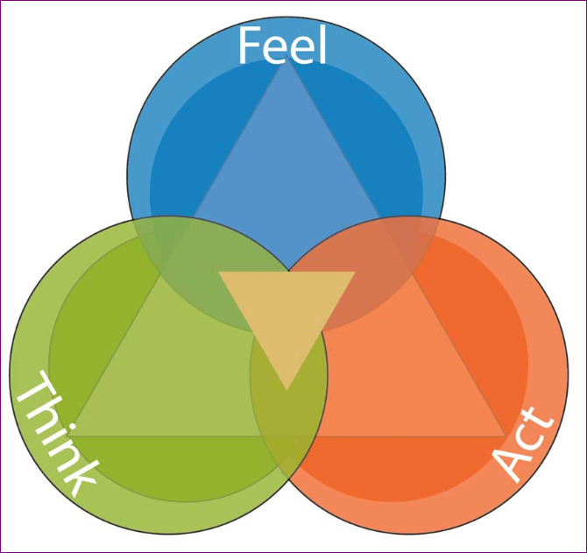
- Step One: For World Peace, Accept full emotional responsibility (ER) for yourself and your life 100% of your thoughts (cognitions), feelings (affect), and actions (behaviors) are created by you!
- "If you cannot find peace within yourself, you will never find it anywhere else." - Marvin Gaye (shot and killed by his father.)
• Keys to a successful and peaceful life.
Managing both your left (cognitive) and right (affect) sides of your brain.
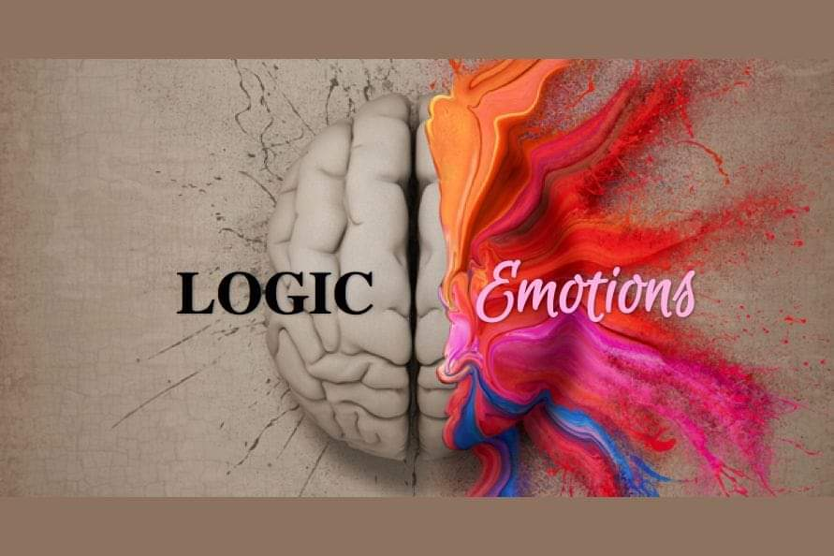
- Step Two: Managing left side of your brain
1. Cognitive, starts with identifying the negative thoughts, meaning, and beliefs that are keeping you from feeling peace. (IQ)
- “Men are disturbed not by things, but by the view they take of them.” Epictetus 55 A.D.
- “As a man thinks in his heart, so is he.” Psalms 23:7
2. Change cognitive beliefs, that create the emotions that keep you from feeling peace then...
- Albert Ellis’s Irrational Belief Systems
- Learn to accept, understand, learn from, the process.
Step Three:
- What you think, believe determines your feelings (emotions) behaviors.
- Learn to manage your cognitive left-brain thoughts and beliefs,
- Left-Brain: (logical side) identify negative thoughts & emotion.
- Irrational Negative Beliefs.
- Event Meaning Feeling Behavior (EMFB) Worksheet.
- Put your existing generalizations, beliefs, and meanings into the EMFB Worksheet.
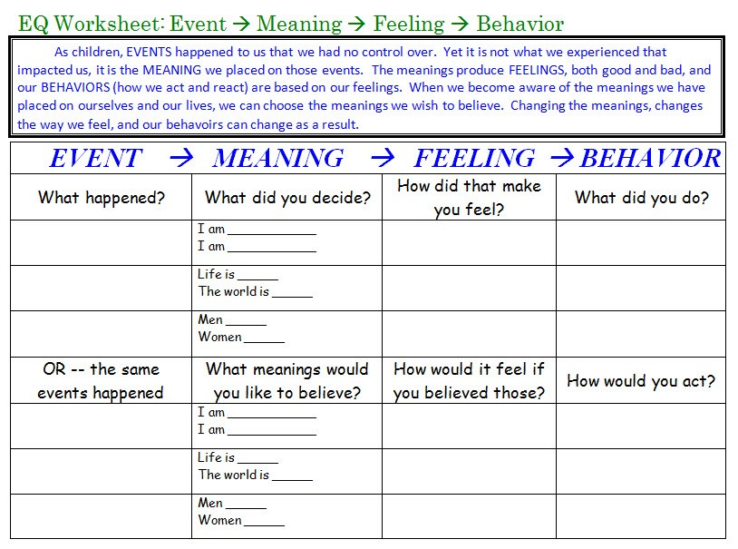

- Look at results and consider your need to be right about each one.
- We keep the meanings and beliefs intact by telling ourselves we are ‘right’, and we look for evidence to prove that we are right.
- Adjust them so they work better for you (#SpinIt2WinIt).
Create new beliefs and meaning that feel better and work better for you.
- Consciously live as if the new beliefs are true for you, find new evidence. . .
- Set up a support system to encourage your change.
- Managing your Right-Brain (affective side). It thinks in pictures and flashbacks. What it sees, it assumes is real and happening now.
- The following are symptoms of negative thoughts and beliefs:
- Anxiety
- Fear
- Anger, Rage & Hate
- Sadness & Grief
- Guilt & Shame
- Depression & Powerlessness
- To release negatives, right-brain emotions (#FeeIt2HealIt), you can change your negative right brain pictures by:
- “Negative feelings expressed as strongly as they are felt in the body, will reduce in intensity, and are free to change.”
- Replacing negative pictures with positive pictures through visualization.
  - Find or create positive pictures to counteract the negative ones. -1 + +1 = 0, no effect.
Step Four: Once you have found out how to live peacefully. . .
- Find other peaceful souls. . .
- Build peaceful relationships. . .
- Share your journey towards peace with others.

