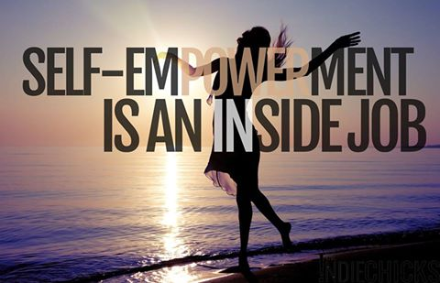  OCt 20-22, 2017  New DirectionS  Emotional Intelligence  Weekend Fresno  Emotional Breakthrough Workshop  For over 30 years, we’ve been helping people with issues – abuse, trauma, abandonment, grief, anger, guilt and more – empower themselves to push thru negative programming, to become the YOU you’ve always wanted to be. Find safety, empower your feelings, heal your past. Let’s create an amazing present, and future, together!  Be bold. Be brave. Be YOU!   | Emotional Mastery:  Take Control of your Thoughts, Feelings & Emotions  ────  KNOW you.  EMPOWER you.  ENJOY you!  ────  Turn Negative Feelings into Positives  ────  Become a Therapeutic Person, for Yourself and Others  New Directions  @ VMS Family Counseling  2350 W. Shaw Ave, #144  Fresno, CA 93711  (916) 599-8597  NewDirectionsWorkshop.com  Friday evening, Sat & Sun  Oct. 20-22

