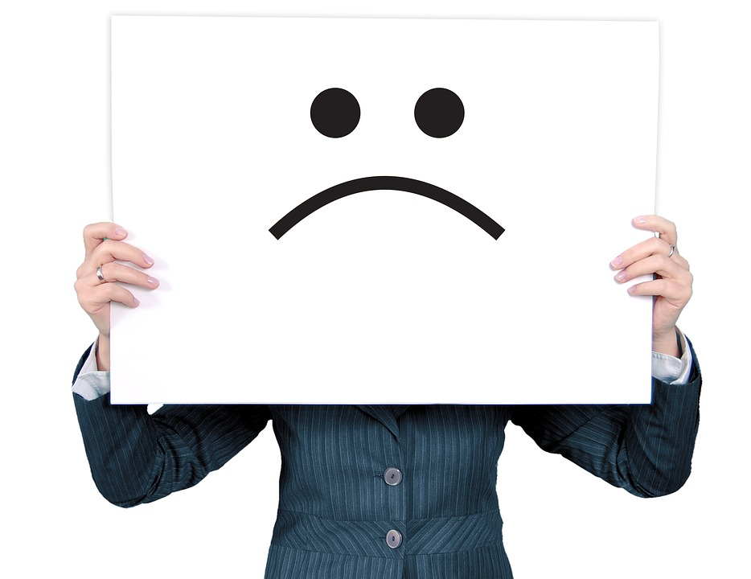

How to Keep Our Feelings From Controlling Our Lives

We all think we’re making our own choices in life, but most people really are not. Anyone who’s wondered why they keep making the same bad choices and mistakes over and over (even though they “know better”) has experienced this emotional hamster wheel.

So, why does this happen? The reason is simple: most of us walk around being controlled by feelings that we’ve been avoiding, denying or compensating for since we were kids. But just because we don’t acknowledge them doesn’t mean they’re not there.

We can think we’ve escaped, but the evidence that we haven’t is that we’re still stuck in the same endless loops:

- we keep having the same fights
- we keep dating (or marrying!) the wrong people
- we keep doing behaviors that hurt others (and ourselves)

One of our clients, Michelle, knew this cycle all too well.

Michelle had felt alone and isolated since she was a little girl. Her dad was abusive and to try to stay safe, she soon developed ways to shut down her feelings.

When she got older, she turned to alcohol and other crutches to help keep the feelings at bay, while to all outward appearances, she was leading a “normal” life. Even though she eventually got married and had kids, she still felt numb.

The problem was, the less she allowed herself to feel her feelings, the more they controlled her life. Anger was all she could express, and lashing out was the way she related to people. It would happen over and over again, and then she would feel guilty and ashamed for acting that way.

“I can’t believe I just did that AGAIN,” she would think.

Her behavior was hurting her relationships and her career, as well as making her miserable. She knew she needed to change…yet her long-repeated patterns seemed automatic and out of her control.

Then she heard about the New Directions Workshop.

It taught Emotional Intelligence, or EQ. New Directions was three-day in-person event with a group of people who all wanted to finally face their past and their feelings so they could master their lives.

“The first night, Friday, makes you feel totally safe,” Michelle says. “I saw other people
dealing with similar issues, and I wasn’t alone.”

The three days had her looking at her own feelings and those of others in a whole new way, and opening up in ways she had not been able to do in years.

Now she has tools that help her recognize and own her own feelings, and that let her empathize with people in her life much more than before. She has new ways of handling all kinds of situations with power, compassion, even humor — instead of anger.

The little girl who trapped her emotions inside has been set free from decades of bondage. And Michelle has never been happier.

Here’s what she says about the New Directions Workshop:

“It’s because of this program, that I am who I am today. I wouldn’t have anything if I hadn’t learned to deal with these feelings. Now I finally get to be me. “

The next New Directions Workshop is happening August 18-20 in Fresno, CA.

[[LINK]]

Michelle is one of thousands we’ve helped over 30 years. What will change in your story after New Directions?

Go here to find out!
[[LINK ]]

People come away after just three days with results like:

- Increased self-esteem
- Relief from anger and depression
-a clearer sense of purpose
- a renewed excitement for life

… and so much more!

Everyone owes it to themselves to get free of the patterns that have been holding them back, and get rid of some of the emotional baggage they’ve been carrying for years. It’s never too late. Why not start that new life now?

Space is limited so everyone gets heard — reserve now:
[[LINK ]]

