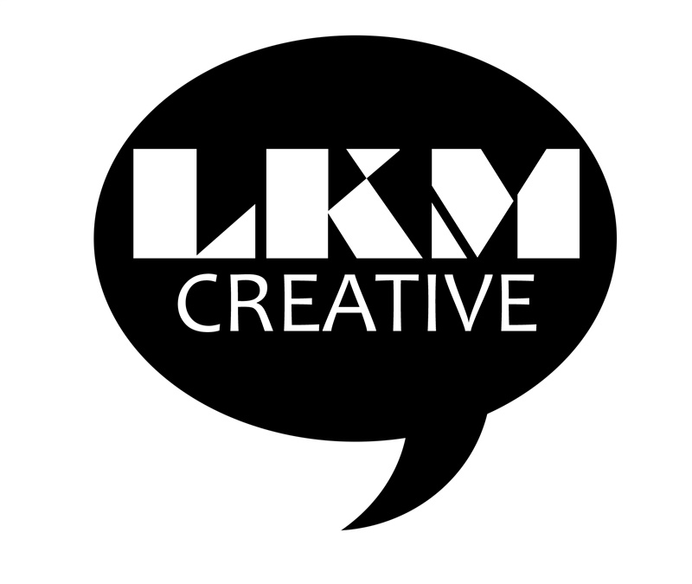
New Directions Workshops: 70” Video Script

Terminology:
MVO: Male Voiceover

Time | Audio
00:00  00:14  00:27  00:45  01:10  END | WARM, UPBEAT MUSIC TRACK BEGINS…  MVO: They always say: Just get over it. It’s not that bad. Cheer up. What “they” don’t understand…is that you CAN’T just get over it. You CAN’T cheer up when your feelings and emotions…are working against you!  MVO: While Emotional Intelligence DOESN’T come naturally to ALL of us, it CAN be learned by ANY of us! Join us for our empowering New Directions Workshops…taking you from victim…to survivor.  MVO: No matter what you’re going through, there is ALWAYS hope. YOU are in control of every fiber of your being. Our humble sessions are 100% safe and comfortable. We don’t just scratch the surface. We dig deeper to access the root of your problems, unlocking life-long results.  MVO: It only takes one week to save your future. Change could be closer than you think – however - you HAVE to WANT it! Are you ready to live your life under your terms? Fill out our form now, and let’s redirect your life into a New Direction! It’s not about changing who you are. It’s about accepting who you are…and mastering your emotions once and for all!  MUSIC ENDS.

