COGNITIVE AFFECTIVE BEHAVIORAL THERAPY,
CABT
Events EMFB

CABT is based on Event Meaning Feelings Behavior (EMFB).
The way you think determines the meanings you put to situations; the meanings then determine your feelings, and from your feelings, you then choose your behaviors.
You were a blank slate when you were born, except for two emotions that came with your physiological makeup. These two feelings you were born with are the fear of loud noises (the startle response) and the fear of falling. All other feelings are learned. You were not born with the fear of snakes or even small bugs. As a baby crawling around on the floor, you were just as likely as not, to pick it up and put it in your mouth.
Except for the two emotions you were born with, all the rest are learned. So, where did all your other feelings come from? EMFB answers how you create your emotional feelings of anger, joy, fear, grief, excitement, depression, and hate.
EMFB stands for EventMeaningsFeelingsBehaviors. In your environment, something happens, someone does or says something, a fire truck runs into a car, your father comes home and beats your mother, or someone gives a speech. Events happen.
From the moment you were born, things have been happening all around you. It is your job to make sense of what your eyes, ears, and mouth are experiencing.
Imagine being whisked away to a distant planet where everything is different from what you use to breathe, to the creatures and world around you, which you have no context for. You cannot stand, walk, or even crawl. You are at the mercy of strange beings you have never experienced.
It is your job as a baby to start making sense of what you are experiencing. You are hanging upside down for most of nine months. Now, people want to hold you the other way. Everything is new, strange, and different. You are figuring out what feels good, what hurts, and what can hurt you. You are figuring out if the world is a safe place or if the world is a dangerous place, and that you are not safe in this dangerous place.
Things are happening all around you, and you are making decisions about your world, yourself, and others. There is no right or wrong; everything is just part of your maturation process.
Once something random or specific happens, you will consciously or unconsciously attach a meaning to that Event. This is an ongoing and changing process of attaching meanings to people, events, and words that will last the rest of your life.
Meanings EMFB
Words have no meanings. You will never find the meaning of a word in the dictionary. The dictionary gives you only the definitions of words. Thinking is what you do to create meaning. “That is what I said, but that is not what I meant.”
Unfortunately, most people do not realize that they think. They believe they are the victims of thoughts, not the creators of thoughts. John is depressed because he believes life is overwhelming. Life cannot be overwhelming. Only what John thinks about life makes it feel overwhelming to him. If life is overwhelming, then everyone in the world would feel overwhelmed!
Two soldiers are on the battlefield; both get blown up in their Humvee. Both lose limbs. However, one ends up with PTSD, and the other does not. Trauma does not create Post-Traumatic Stress Disorder, PTSD. It is what they believe (the meaning they place on the event). One soldier now believes that the world is dangerous and that he is no longer safe in this dangerous world. So, he sleeps in his closet with his rifle. The other soldier concludes that the world is somewhat safe and somewhat not, but he can take care of himself when the world is not safe.
You feel the way you do right now
Because of the thoughts you are thinking at this moment.
---David Burns MD, Psychiatrist

Affirmations are a great example of your thinking. Everyone has affirmations that they tell themselves. Some thoughts will be positive and life-affirming, while others will be negative and self-defeating. Where are you getting these messages? Are they from outer space? Or, are they learned from birth? The good news is that what is learned can be unlearned and replaced with new and supportive thoughts (affirmations).
You really can think anything you choose to think! You are not a victim of your thoughts!
After you think something, you will feel something. You can bring about change through combinations of feelings, logic, and behavior. This will include working with both sides of your brain, the logical and the affective side him him.
Feelings, EMFB
Your feelings directly result from the meanings (thoughts, conclusions, beliefs) you have placed on events, people, and words. It is within your power to change your meanings.
If you are pained by external things,
It is not they that disturb you,
But your own judgments of them.
And it is in your power to wipe out that judgment now.
----Marcus Aurelius 121 A.D.

Your brain has two operating modes. One is cognitive (logical, rational, and thinks sequentially), and the other is affective (emotional, feeling, and thinking in flashbacks--- pictures). Your feelings can be generated from either part of your brain. You cannot logically make the pictures in the affective side of the brain just disappear through logical and rational arguments.

Cognitive, Rational, and Behavioral therapies, such as CBT, have been proven very beneficial to get therapeutic change in clients. However, CBT has proven less than that in working with traumatic problems such as PTSD, Dissociative Behavior, and issues stemming from traumas related to rape, molestation, car wrecks, and acts of nature.

The first step is establishing from which side your emotional dysfunction is coming. If it comes from your left side -- your beliefs, values, and expectations -- then you will need a person who uses a cognitive approach and techniques.

If it is determined that your emotional issues stem from flashbacks (pictures), either seen or not seen, then you would want to look for a therapist familiar with right brain therapy. Not all flashbacks (pictures) are seen, yet they can still be experienced in your body. For example, my client was relaxed and looking out at the birds when suddenly, she had a major anxiety attack. She thought she was dying. She was rushed to the hospital, where she was told nothing was wrong with her. She just had an “anxiety attack,” “It is all in your head.”

This is when you need to find a right brain therapy therapist who can “erase” the traumatic pictures.

When it comes to erasing traumatic pictures, try thinking of it as a: -1 = -1. Now, what happens if you add to the -1 +1 = 0? A negative image paired with a positive image equals zero. The therapist does this when they have you re-enact the negative experience and replace it with a positive one.

Behavior, EMFB
You can change your dysfunctional behaviors using any of these three categories—Cognitive, Behavioral, and Feelings (affective). However, unless there is a permanent change in the Feelings, the behavior will remain unchanged.
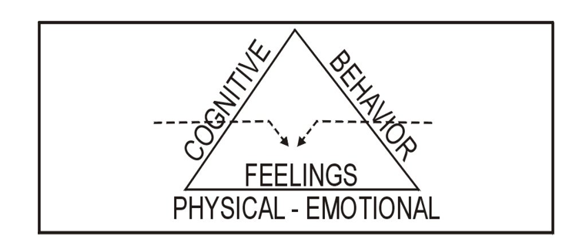
Using a behavioral approach to change, I had my client list everything he was afraid to do, starting with one as the most afraid of and ten as the least fearful. The assignment was for him to do the least fearful thing (which he was sure he could do) and do it until he was no longer fearful. Then, he was to take the next least fearful thing, and do it until he was no longer fearful. After a year or so, he could do the whole list without fear. By the end of the year, he was confident to try all sorts of new things.

My client was molested for years and then, as a young adolescent, raped. Now, as an adult, she will not leave the house. I used a combination of behavioral, cognitive, and affective therapy approaches----we talked about the two sides of the brain and how they think differently. We talked about how the right side of the brain is not logical but thinks in pictures, and the pictures cannot be erased by talking about them. And she would need to do is to relive the events (pictures) and relive them! Then, through psychodrama, she would create new pictures of herself as strong and confident. The world would no longer be an unsafe place to live.

The next step was where she role-played being strong, beating on a pillow (while I held it). Literally pushed me out the door, yelling and screaming, “You will never touch me again!!!” Because there were many incidents of abuse, it took several role-playing sessions to change the pictures (flashbacks).

The third step was to return to behavioral techniques. Every day, her assignment was to go to the mailbox, but before she left the house, she screamed and yelled, “You will never ever touch me again,” then walked to the street and got the mail. By the end of her sessions, she could leave the house and even go shopping.

Contact Myron Doc Downing Ph.D. at:
Email: DocDowning103@gmail.com
Website: DocDPhD.com

