The E.M.F.B. Approach to Daily Living

by Aliyah Arif Durrani

An individual’s reality is based on perceptual inferences, i.e., what one sees and derives meaning from, their feelings, and behavioural tendencies. The E.M.F.B. approach, also known as the Event-Meaning-Feeling-Behaviour Cycle (see Figure 1; (Downing, 2013) Downing, M. D. (2013, September 23). Taking Control of Your Life: How to Dramatically Increase your Emotional Intelligence (EQ). https://www.smashwords.com/books/view/360432), is an epitome principle that regulates normal human functioning. Such regulations create awareness of individuals’ potential to actively shape their core perceptions of reality.
The primary tenet of the E.M.F.B. approach is the interaction of the self with external life factors such as events, people, and words. Such factors may be dichotomous in nature, i.e., positive or negative. For instance, a stranger may be kinder and more apologetic when colliding with an attractive figure than with an average-looking person. Despite their paradoxical nature, human beings have a primal bias towards reminiscing about positive memories of the past while disengaging themselves from recalling past negative events. Such personal biases can lead to current emotional disturbances and future physiological problems. According to Daniel Schahter (2001), the act of retrieving memory predisposes an individual to a distorted perception of reality.
The second tenet of the E.M.F.B. approach is meaning, a.k.a., our belief systems. One characteristic feature of the meaning-making process is that it predominantly operates outside of our conscious realm (Welburn et al., 2002; https://www.sciencedirect.com/science/article/pii/S0165032715303025). Thus, creating awareness of our thought processes is the first step towards making logical decisions.
Imagine yourself at the top of a steep hill. You're struggling to see what's at the bottom and whether the seemingly dangerous trek down there is worthwhile. The hill is a radar that measures our awareness of our personal belief system. However, you become frustrated and instead blame your poor vision. Moving steadily, you steer clear of any obstacles along the path, recognising that "one can make logical decisions based on only what one is aware of." Your logical reasoning is thus guiding you towards choosing the best course of action that will allow you to tread the path safely. Awareness is a positive step forward, without which you are on a hazy trail with no clear strategic planning. If you are not mindful of your surroundings, you may end up in a mud puddle instead. As a result, your continual tirade of self-blame could cause you to lose focus on your next crucial step.
Our meanings and belief systems consist of deep-seated schemas known as 'core beliefs'. Core beliefs are generally formed in early childhood and result from our interaction with external life factors such as people and/or our environment (Beck, 2011;https://www.sciencedirect.com/science/article/pii/S0165032715303025). These beliefs may be rational, or irrational based on one’s perception. Negative core beliefs often impede problem-solving abilities, lower self-esteem, and cause interpersonal problems. Such irrational beliefs, when reiterated, become automatic negative thoughts that impact our feelings and actions beyond our conscious threshold. Thus, assuming that at the summit of the steep hill are our deep-seated core ideas, which appear far-fetched from our baseline perspective, our goal is to identify those core beliefs that are implicitly influencing our lives.
An exercise demonstration would help in identifying one's fundamental core beliefs. Recall the hill radar scenario, think of each step revealing a personal assumption associated with one’s core beliefs, and evaluate the statement in reference to oneself (see Figure 2, which depicts Isaac's example). Subsequently, each step leads an individual towards greater self-awareness within their life context. This approach is similar to the downward arrow technique used in cognitive-behavioural therapy (CBT), which assesses one’s underlying thought processes in order to identify personal core beliefs. (Beck et al., 1979; https://www.sciencedirect.com/science/article/pii/S0165032715303025)
Negative core beliefs can be outlined into three distinctive categories: helplessness, unlovability, and worthlessness (Judith Beck, 2005; 2011). Our assumptions about ourselves, the world, and reality often mirror the impressions of our underlying core beliefs. As humans, we endure countless thoughts in a day; therefore, retrieving a specific context-driven incident may aid as a memory cue to examine the cognitive processes underlying the event (see Figure 3 for an example with a few guidelines). Thus, our limited human capacity allows us to define our thinking patterns and assign meanings to external life circumstances, i.e., people, events, or words, by reconstructing and shaping our perceptual lens of reality.

The third tenet of the E.M.F.B. approach is feelings. The subliminal role of our basic emotions, such as anger, sadness, happiness, fear, disgust, and surprise (Paul Ekman), determines our behavioural action tendencies. Our feelings, although described as fleeting moments, create deep and impactful consequences, which may, as a result, be positive or negative.
As stated previously, awareness is a critical aspect in logical decision-making that results in an improved quality of life. In the previous example (see Figure 3), a person is likely to be overwhelmed by feeling inadequate when confronting a large public gathering. Such beliefs of inadequacy may reinforce an individual’s low self-esteem by creating unpleasant emotions like fear and embarrassment. However, an individual possesses the ability to redirect his thoughts or beliefs by forming new, realistic perceptions. The reinterpretation of the event increases one’s likelihood of experiencing pleasant emotions. Thus, when the fear of confronting a large audience is perceived as the ability to overcome one's distress, the individual may experience pleasant emotions such as pride. Therefore, one can determine what to feel based on their cognitive understanding. In other words, our feelings are formed by our current stream of thoughts, and we possess the ability to recreate our inner experiences.
“You feel the way you do right now
because of the thoughts you are thinking at this moment.”
~ David Burns, MD

A narrative of a positive past memory, such as being renowned as a scholar student, may be more consciously remembered than the shame and embarrassment endured while being bullied at school. Such individual biases lead to several coping mechanisms, such as emotion regulation, an increase in positive mood while reducing traces of occasional blue mood, i.e., depression and sadness, strengthening social ties, and having a positive outlook on life (Conway & Pleydell-Pearce, 2000). "Recalling past positive events is an adaptive way to regulate current emotions and enhance future optimism," Dr. Schacter said.
Negative emotions, when characterized in terms of their intensity, are often superseded by positive emotions; this is known as the fading affect bias (Walker, Skowronski, & Thompson, 2003). In other words, events triggered by distressing emotions such as anger or guilt are likely substituted by pleasant-driven incidents (Ritchie, Skowronski, Hartnett, Wells, & Walker, 2009). One reason may include that maintaining a positive self-image elevates one’s level of optimal functioning (Sedikides, Skowronski, & Gaertner, 2004) and improves one’s capacity for introspection. However, reminiscing via selective memory usually takes place due to an individual’s mindset being in a state of disequilibrium or distress.
The affect bias unconsciously creates a detrimental impact on an individual’s feelings and behaviour, wherein the negative emotions typically tend to persist (Freud, 1915/1957). Consider an example: Isaac, being the middle child, has lived by the affirmation "to forgive is to forget ''. During his childhood, he felt overshadowed by his siblings in many aspects, i.e., being less talented and capable, having his opinions disregarded in consensual decisions, and having his needs neglected. He felt hurt initially, but his sadness went unnoticed. Eventually, he learned to express his sorrow and grief by portraying himself as a "helpful child" to his loved ones. Although Isaac’s behaviour may be labelled in a socially acceptable manner, sometimes "too helpful can be hurtful." Thus, while others may perceive him as a helpful child, there may still be a gleam of sadness that occasionally penetrates his self-worth and actions.
From the above example, it may be ascertained that despite Isaac developing a personal coping strategy for himself, he unconsciously associated certain belief systems, i.e., "I’m worthless" or "I’m unlovable," as his present reality. Such unwarranted beliefs, although out of his conscious awareness, may have had an adverse impact on his feelings and behaviour by generalising across different aspects of his life.
Negative emotions that persist, which usually originate from adverse life circumstances, are related to a poor quality of life. Adverse Childhood Experiences (ACEs) are described as early experiences that negatively impact one’s current psychological and physiological functioning. ACE is outlined into three distinctive categories: childhood abuse, including emotional, physical, and sexual abuse; neglect, which includes both physical and emotional neglect; and household challenges, described as increased exposure to substance abuse, mental illness, maltreatment from a mother or stepmother, parental separation or divorce, or a family member who has been detained in prison [3]. Research studies have primarily focused on the association between early dysfunctional experiences and the prognosis of adult wellbeing and subsequent health-related risk factors [1–3].
According to such findings, there is a strong existing correlation between having one or more traumatic childhood experiences and the later development of diseases like cancer, ischemic heart disease, liver disease, and chronic lung disease, as well as adopting unhealthy behavioural patterns like smoking, drug use, obesity, and risky sexual behaviour. For example, in dysfunctional households, children who have experienced parental separation or had an alcoholic parent(s) have a higher risk factor of adopting similar coping mechanisms, such as drug abuse or excessive smoking. According to study findings, such behavioural patterns develop at an early age as a result of exposure to multiple negative stressors, which can lead to severe chronic problems like cardiovascular disease or chronic heart disease in young adults or later in life [3]. Therefore, it is crucial to identify early childhood experiences that result in high negative emotions and high-risk behaviours, resulting in poor physical and mental health outcomes.

Acceptance is, thus, the second key pillar for an individual to lead a high-quality life. The process of acceptance is characterised by self-accountability or competence-based mastery, i.e., understanding one's own strengths and limitations. It is vital to acknowledge that a person’s shared perception is the closest lens to his reality and is thus primarily responsible for regulating his thoughts, feelings, and actions.
The fourth tenet of the E.M.F.B. approach is behaviour or action tendencies. The interpretation of an event leads to the experience of dynamic emotions or feelings within the individual. Based on this, the person is directed to the action-or-no-action stage. Therefore, one decides how to act based on one's current emotional and cognitive state.
Research findings suggest a link between various types of childhood abuse, such as physical, mental, or sexual abuse, and adolescents with distorted eating behaviors, resulting in obesity and an underweight BMI. Adolescent boys who experienced childhood physical and sexual abuse were more likely to have an above-average Body Mass Index (BMI) or be obese, but adolescent girls were more likely to be underweight [1-2]. Thus, childhood adversity such as abuse was reported to cause individuals to feel shame and anxiety by perceiving themselves as victims, leading to the development of ineffective coping strategies such as unhealthy eating habits, physical inactivity, or excessive suicidal thoughts to overcome their emotional distress [2-3]. According to a study, those who identified themselves as victims of sexual abuse were more likely to be in psychological distress [1]. Furthermore, increased exposure to childhood-related trauma in adolescents reinforced smoking habits, resulting in later addiction and a poor prognosis [3].
Early detection of high disease-related occurrences at a later age requires the individual to have a strong relational network, including family, friends, etc. Such support networks increase the likelihood of preventing further deterioration by encouraging the individual to seek expert care. Furthermore, professionals who provide assistance must incorporate the E.M.F.B. approach within their therapeutic paradigms and promote it. A case example illustrated in Fig. 3 implements the E.M.F.B. technique with proper guidelines. In order to promote a common understanding that personal vulnerability is an essential aspect of our lives that may be transformed within the limitations of human potential, it is vital to advocate for this knowledge in the general public.
Think Positive -> Feel Positive -> Live Positive!

“Love, given and felt, is dependent upon the ability to be present, attentive, attuned, and responsive to another human being. This glue of humanity has been essential to the survival of our species and to the health and happiness of individuals. And this ability is based upon what happened to you, primarily as a young child.” Oprah Winfrey, Bruce D. Perry; What happened to you? Conversations on trauma, resilience, and healing

References

- Jia, H., Li, J.Z., Leserman, J. et al. Relationship of Abuse History and Other Risk Factors with Obesity Among Female Gastrointestinal Patients. Dig Dis Sci 49, 872–877 (2004). https://doi.org/10.1023/B:DDAS.0000030102.19372.52
- Veldwijk, J., Proper, K.I., Hoeven-Mulder, H.B. et al. The prevalence of physical, sexual and mental abuse among adolescents and the association with BMI status. BMC Public Health 12, 840 (2012). https://doi.org/10.1186/1471-2458-12-840
- Felitti, V. J. (n.d.). Relationship of childhood abuse and household dysfunction to many of the Leading Causes of Death in Adults. https://www.ajpmonline.org/article/S0749-3797(98)00017-8/abstract
- Lieberman, C. (2021, April 2). Why we romanticize the past.The New York Times. https://www.nytimes.com/2021/04/02/smarter-living/why-we-romanticize-the-past.html
- WALKER, R. W., & SKOWRONSKI, J. J. (2009). The fading affect bias: But what the hell is it for? https://www.niu.edu/jskowronski/publications/WalkerSkowronski2009.pdf
- Anna Katharina Schaffner, Ph. D. (2023, March 3). Core beliefs: 12 worksheets to challenge negative beliefs. PositivePsychology.com. https://positivepsychology.com/core-beliefs-worksheets/

(Daniel Schacter, The Seven Sins of Memory: How the Mind Forgets and Remembers)

Notes:
positive views regarding the lovability of the self, the trustworthiness of others, and the safety of close relationships (attachment security) are associated with good mental health and resilience (see Mikulincer and Shaver (2007). Internal working models comprising negative views of either or both the self and others, and resultant doubts over the safety of close relationships (attachment insecurity) are related to poor mental health, including depression and anxiety (see Mikulincer and Shaver (2007)

Appendices

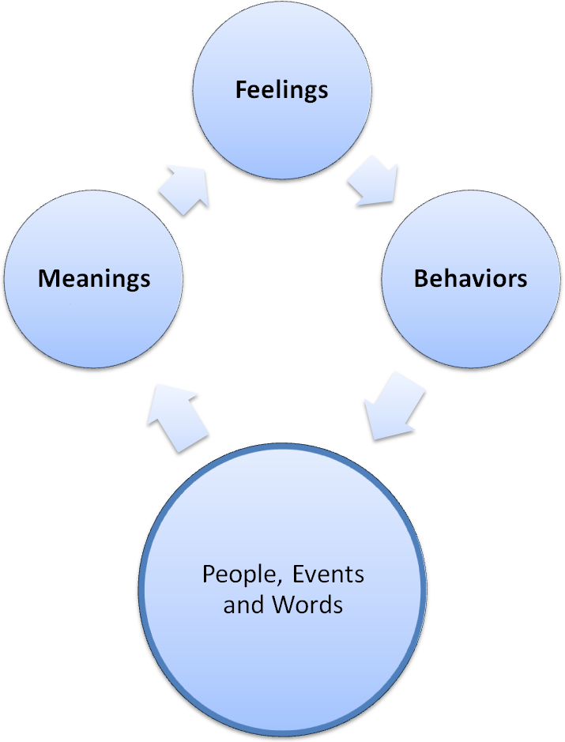

Figure 1. The E.M.F.B. Cycle i.e. Event 🡪 Meaning 🡪 Feeling 🡪 Behaviours

“I will always be there for others.”
↓ (What does that mean about you?)
“I will always prioritize fulfilling others' needs.”
↓ (What does that mean about you?)
"My needs are not as important as others."
↓ (What does that mean about you?)
"I am not sufficient."
↓ (What does that mean about you?)
"I am worthless."
Figure 2. Flowchart Diagram using Isaac’s case example

Redirecting Core Beliefs

  - You can assign new meanings to people, events, or words.
  - You can reprogram your brain to change perspectives.
  - Belief systems were originally created for our good or protection.

 | Automatic thought/ belief | New thought/ belief | How to practice the new thought
Situation | It's my turn next; I am surely going to make a fool out of myself during my presentation! | I am going to do this, as it may be my last shot at it! | Channel my inner self-confidence and practice positive self-talk.
What does this mean about me? | I am no good and an embarrassment. | I am not going to give up and will try to overcome my fear. | Recognize and confront my fears as much as possible.
What does this mean about others? | They will judge me negatively and outcast me. | Some people may choose to listen as I speak, while others may not. | Focus on those actively listening and use good social communication cues for a better interaction.
What does this mean about the world? | It is a difficult world to live in. | It may be difficult to confront similar situations, but opportunities don't come easily. | It is better to have an opportunity than to have none at all.

Purpose of the thought | To cocoon myself within my comfort zone. | To overcome fears or irrational phobias. | To actively cope with and tolerate distressing events.

Figure 3. Redirecting Core Beliefs Worksheet
It is important to redirect your belief systems to follow these basic guidelines:
- Flexible and preference-based: Recognize that you are capable of both success and failure. Instead of “I must not fail”, think “I prefer not to fail”.
- True and consistent with reality: Stop and analyze situations before being overwhelmed with emotions. Include If/Then statements, like “If I fail, I will then..."
- Balanced and non-extreme: Resist using judgmental, absolute, or harsh labels to describe yourself, others, or the world.
- Consciously arrived at: Think and practice new healthy beliefs by following the 3PS: practice, patience, and persistence.
- Helpful to you: Your new belief systems assist you in fulfilling goals and enhancing your emotional well-being.

