Myron Doc Downing PhD
Author | Therapist | Seminar Leader | BA, MSW, PhD

Excerpt from Docs 1972 thesis

Chapter 1

INTRODUCTION

What Is Mental Health?
It is important to have some concept of what mental health is in order to be able to measure progress or to know if we are successful. If we are not sure in our minds what the goals of mental health are, then there can be doubt on what behaviors should be changed and what behaviors should be left alone, what attitudes should be changed and what attitudes should be accepted. If we are not sure where we are going we are liable to end up someplace else!

In attempting to define mental health in operational terms, several basic assumptions will be stated as givens: first, all behavior is learned except for the autonomic responses such as sneezing eye blinking, and stomach growling. Second, all attitudes are learned. Third, what is learned can be unlearned.

At this point we have some idea that we are in the learning and unlearning business, but it is still pretty unclear what is to be learned and what is to be left alone and what is to be unlearned. Most of our theories of personality change are derived from experiences of this author. Sigmund Freud found that when he did certain things his patients seem to get better, so in a very general way we can say that Freud used the techniques which in his opinion worked. He integrated these techniques into a personality theory that would explain why his techniques “worked.” Throughout his life, for it was constantly modifying and changing his theories depending on the success or failure of the technique that he tried. Basically, the same can be said for all personality theorists such as Ellis, Rogers, Perls, or Skinner.

To look at these theories or listen to their authors leaves the impression that each man was working on a different species of mankind. For instance, Pearl states, “it took us a long time to deep bunk the whole fording crap.” Skinner, on the other hand, feels it the behavior that is important while Ellis with his Rational Emotive Therapy, takes a more cognitive didactic approach. Each man in turn claims success, claims that his theory “works” and can specifically prove that people have been helped to change their behavior to his personality theory that each put forth.

The problem we face is which theory is correct if all theories work to some degree or other. How can theories which are mutually exclusive all produce beneficial behavioral change? Perhaps a closer look is needed at the area of man that each theory purports to be concerned with. Freud and Ellis to a large degree deal with the area of cognition, insight therapy, and new educational material; Rogers and pearls seem to be concerned with the emotions and feelings and man’s awareness of the feelings in himself the tend to view man as self-actualizing when placed in a safe environment. Skinner, on the other hand, tends to deal with more behavioral types of responses things acquired through habit and learn through poor conditioning.

TECHNIQUES THEORIES FOCUS
ELLIS Didactic
COGNITIVE

FEELINGS

BEHAVIOR
FREUD Insight
PERLS Awareness
ROGERS Positive Regard
SKINNER Stimulus-Response

What seems to have emerged then are the three basic areas from which man can be therapeutically reached: 1) cognitive, 2) behavioral, and 3) feelings that include both physical and emotional feelings.
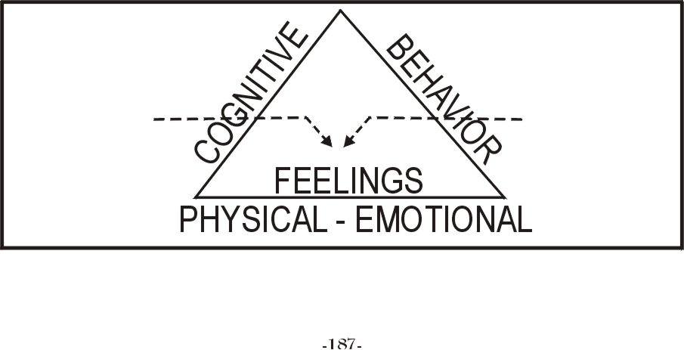

It is the bias of this writer that feelings are the basic controlling factor in all human behavior. When I itch, I scratch. When I am hungry, I go to the icebox. I go to church because if I did not I would feel guilty, or I do not go because I do feel guilty; I wear certain clothes; I act certain ways because I fear rejection. If I conform and if I am more like everyone else, then I have more of a chance of being accepted and loved. Or I rebel— I strike out because I am angry or I am afraid that I am not free. I then let my hair grow and where strange looking clothes in an attempt to prove to myself that I am free.
But not all my feelings are clear. Some of them are often confused and contradictory; I live and I hate at the same time, I am angry and yet deeply in love with the person I am angry with. I drive along a mountain road and experience anger, frustration, and loneliness and wonder what it would be like to drive off the edge of the road while at the same time I am aware that I am really hurt and I do not like paying. Feelings that are contradictory or confusing and I do not like confusion, so I deny the feelings that I cannot accept and pretend they do not exist while I listen to the song “Pretend That You Are Happy When You Are Sad.”
I am trained from a very early age to deny what I feel; I am told that what I feel really is not what I feel I am told “jump up That! That really did not hurt. Be brave and smile. Big boys do not cry.” By the time I am grown I am lucky if I can recognize any of my feelings much less be able to express them. Therefore, Isaac Rubin in The Angry Book points out the problem that occurs when we lose track of awareness of what we are feeling. Ruben puts it this way: “Actually, the greater their awareness – – that is, the closer they are to what they really feel – – the last chance there is to lose control.” This will be covered in more detail in the next chapter.
Based on what we have covered thus far, this writer suggests an operational definition of good mental health as: First, the ability to know what we feel when we feel it, second, the freedom to accept what we feel when we feel it, and third, the skill to express it in acceptable ways. With this definition a counselor could now choose any number of therapeutic approaches or therapeutic biases that will aid the client in achieving one or all of these goals. A good counselor is one who age the client in becoming aware of what he feels, helps them in accepting what he feels and helps them discover acceptable means of expressing these feelings. What happens then is that as we come closer and closer to these goals, we begin to experience growth and constructive change in our lives.
Now there is no such thing as complete or absolute good mental health there is no such thing as a completely insane or sane person. The most insane person in any institution has some degree of sanity with which he holds himself together, while the most sane person from time to time under extreme stress will experience periods of “craziness.” Since we are all dynamic (changing) human beings, we find ourselves constantly moving on a continuum somewhere between sanity and insanity. We do not have the choice of what we feel but if we are aware of what we feel we do have the choice of how and when to express these feelings. It is these kinds of options that give us the feeling of stability and well-being.

