Myron Doc Downing PhD
Author | Therapist | Seminar Leader | BA, MSW, PhD

MAKING PEACE WITH ANGER
Your Own and Others Too

Most people find that they are not capable of making peace with anger.
There are two problems when it comes to reconciling anger and peace.
First, You cannot make peace with anger unless you can recognize anger in yourself and in others too.
Second, you cannot make peace with anger if you are afraid of anger in yourself and in others too.
Let us start by recognizing anger in yourself. But, you say, "I never get angry, I just get upset." Anger comes in degrees, starting with just a little bit of anger. Most people call this annoyed, irritated, and so on up to hate and rage.
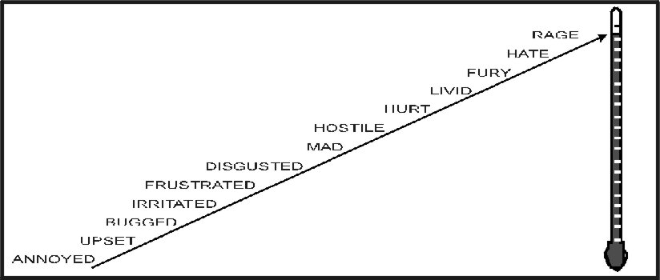
People feel the full range of feelings. Birds fly, fish swim, and people feel. It is possible to repress your feelings to the point that you are no longer aware of specific feelings. When you do this, then that feeling will be manifest in some other form.
To reclaim feelings that have been repressed, such as anger, you will need to confront your false beliefs around anger. Here are some of the irrational and false beliefs that many people hold:
- Emotional Pain Is Terminal, "I can never stand to be hurt that way again." If you have ever hurt so much emotionally that you hurt physically, then you know that this is a false statement, because you experienced that pain and are still alive. That pain proved only one thing, what a gutsy, healthy person you are! If you went through it once you can, go through it again.
- Anger is both physically and emotionally hurtful to yourself and others. Not true! No one has ever gone to jail for being angry. It is how you express your anger that can put you in jail. It is not what you say; it is how you say it. In EQ, you can learn how to be yelling, screaming angry in ways that strengthen your relationships with yourself and with others.
- "He who raises his voice first, loses." The concept of "losing face" is another misguided and false concept. Raising your voice does not mean you are out of control. Passionate people raise their voices all the time. Probably, a better idea would be "He who loses control first, loses." You can be out of control without raising your voice. You can raise your voice and be in complete control.
Are you willing to recognize and accept your anger? Are you able to recognize and accept anger in other people? If you are, then you are well on your way to making peace with anger. The only people who never feel any degree of anger are dead! Or, they are lying to themselves.
There are no good feelings or bad feelings. It is what you do with your feelings that can bring peace or conflict to your life. Mahatma Gandhi was a truly angry man. He hated the British being in India. Nelson Mandela used his anger to destroy apartheid in South Africa. Martin Luther King used his anger to lead the fight against segregation in America.
The goal in EQ is not to get rid of anger. It is to use your anger and hate in nonviolent ways, to change the world towards peace.

Feelings are not good or bad! They just are.
EQ Skills
Verbal Aikido is a variation of the martial art of Aikido that uses words to accomplish the goal of disarming your "opponent." Both are performed by blending with the motion of the attacker and redirecting the force of the attack rather than opposing it head-on.
The goal of Verbal Aikido is to strengthen relationships, help resolve conflicts, and bring others emotionally closer. To do this, you need to be clear about where you are coming from and where the other person is coming from. This requires that you be aware of what you feel when you feel it and that you be willing to accept all your feelings and express them in constructive ways.
To be able to do this requires a clear understanding of the To Me rule. There are two parts to this rule. The first part helps you not to take anything that is said or done personally.
The To Me rule says: What someone says about me, says NOTHING about me, it only tells me about you. Some examples: If someone says to you, "You have three heads and fifteen legs." What did they say about you? NOTHING! What have they said about themselves? That probably, they have a mental problem.?
"You are so ugly that you would scare a mud fence." Now, what are they saying about you? NOTHING. What did they say about themselves? Perhaps, that for some reason, they are incredibly angry at you.
"You are the most beautiful person I have ever seen." Now, what are they saying about you? Still NOTHING! In EQ, we learn that two people sitting side-by-side can see things very differently. So, anything that they say is just their viewpoint.
Apply: Think of a specific time when someone has hurt your feeling, especially badly by what they said or did. What did they say about you? If you cannot say NOTHING, then you need to reread the To Me rule.
Here is the other side of the To Me rule. Whatever you say about someone else, says NOTHING about that person, but it says everything about you. If you were to say, "The PM is a sexist, racist, homophobe." What did you say about the PM? NOTHING. A word to the wise, whenever you are using putdowns, name-calling or sarcasm, what you are telling those that are listening, is that you are a judgmental, angry, and perhaps, a scary person to be around.
Three Anger Tools
Using anger as a tool and, at the same time, recognizing it as an emotion.
- FIRST TOOL: Anger to reject and keep somebody out of your life forever and ever. This tool is not where you are angry because you just want some space, and after you calm down, you will want that relationship again. This tool is using anger to get rid of somebody permanently.
- SECOND TOOL: Anger to manipulate. Using anger to manipulate is not necessarily a bad thing to do. "DO NOT RIDE YOUR BICYCLE IN THE BUSY STREET." Parents will often use anger to manipulate children to clean their room, get their lessons done, etc. Bosses may use anger to manipulate their employees to work harder. Many employees are fearful when their boss yells at them because they think the boss is going to fire them. If the boss wanted you fired, he probably would not even raise his voice. He would just say, "Do not bother to show up tomorrow; you're through here." Final note: Using anger to manipulate when you are in a close relationship with someone is a very destructive thing to do.
- THIRD TOOL: Anger to feel good! Some people call it venting. This tool is where you express your anger as intensely as you feel it. But, it is not directed at a person. I know a holy man who, when he got angry, would say, "I am so angry I could spit nails." This tool is not to be used as a putdown, sarcasm, or threat. It is used to get rid of the emotional buildup of energy. Confucius said, "To repress a feeling is to give it unlimited power."
Apply: Think of a specific time someone has been yelling and screaming at you. Which one of these three anger tools were they using? Were they trying to get rid of you forever? Were they trying to manipulate you? Were they just venting, and you became afraid of their anger?
EQ suggestions to respond with when anger is involved:
- I am confused about _____. Can you help me understand ____? (Instead of "I am angry about____.)
- Would you be willing to _____?
- How do you want me to respond to you when you don't do what you have promised to do?
- Never-the-less,____. Or regardless____. (Helps you stay focused) "Nevertheless, that is what I feel. I wish I had a button I could push and not feel it."
- That is not acceptable.
- I would be less than honest with you if I don't tell you_____.
- I feel_____.
- I hear you saying_____.
- May I suggest_____.You sound extremely upset and powerless. I would have been upset also if that had happened to me. (Validating the person's feelings)
- That has got to be very upsetting. What do you see as your options?
- What do you see as the worst that could happen? What do you see as the best that could happen?
- Thank you for sharing your anger with me. Or, thanks for loving me so much. (The opposite of love is not anger or hate; it is indifference. Anger is a part of love; a statement of how important you are.)
- When someone asked you to do something that you do not want to do, respond with: If I do what you are asking, I will feel resentful and bitter; however, I love you enough that I would not do that to our relationship. (An excellent, assertive way of saying, no.)

It is just as important not to use specific phrases or words when using EQ responses. Here are some suggestions to not use when anger is involved.
- No WHY questions: why questions are usually heard as accusatory statements. "Why did you do that?" It is understood as "You should not have done that." And, it usually elicits a defensive response or the person quits talking.
- Do not give answers or try to fix the problem unless the person asks for suggestions. Then, give at least a couple of suggestions and ask, "Which do you think would work for you?"
- No name-calling. Using the b or f word will never improve a relationship. If you resort to name-calling, you are saying that you want to make the relationship worse!
- No labeling. People often become the labels that are put on them. "You’re irresponsible.” How does an irresponsible person act? Be careful of the labels that you use on yourself, or you may become what you say you are. “I’m so stupid.” What do stupid people do?
- No ordering, commanding or demanding. Nobody likes to be controlled, not even by themselves. They will resist by rebelling or getting even.

EQ has mental health components based on the principle that the way you think determines what you feel and what you feel determines what you do.
In short, this is what it looks like: Something happens (people, events, words) you then put some kind of meaning, expectation, or judgment on what you just saw or experienced. “That was a bad thing. I am going to stay away from that bad thing/person.” This thinking results in you having feelings (determined by the meaning you put on the event) and then, how you feel about something determines what you end up doing.
Have you ever had feelings that you wish that you did not have? Have you ever had your feelings hurt? Have you ever been hurt so much emotionally that you hurt physically? Has someone ever made you so angry that you ended up doing something stupid? Where do those feelings arise? They come from the beliefs, expectations, and conclusions that you have drawn throughout your life!
One of the main principles of EQ is that you choose to think, and you can choose to believe anything you wish to think. And, what you are thinking is what is producing your feelings! Choosing to think is not a new concept.
- “You feel the way you do right now because of the thoughts you are thinking at this moment.” David Burns MD
- “You have the power over your mind – not outside events. Realize this, and you will find strength.” Marcus Aurelius, Roman Emperor
- “If you are pained by external things, it is not they that disturb you, but your own judgment of them. And, it is your power to wipe out that judgment now.” Marcus Aurelius, Roman Emperor
Therapeutic Basis For EQ
EQ has its theoretical orientation in Cognitive Affective Behavioral Therapy, CABT. CABT is a spinoff of Cognitive Behavioral Therapy. CBT was made popular by Albert Ellis and Aaron Beck. What was missing in the CBT approach was the affect/feeling element.
With EQ, this is what happens when somebody says something that makes you feel depressed and you do not know that you are choosing to think. You can choose to put different meanings on what someone is saying. Once you do that, then what you feel and what you do will change.
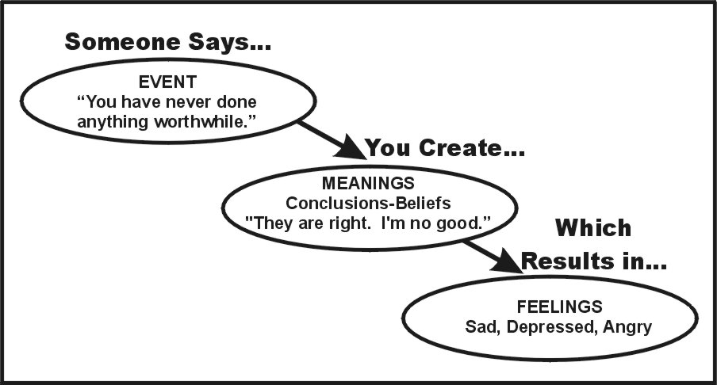
Let me suggest to you another model. This model allows you to have power over both your mind and your body. See below.
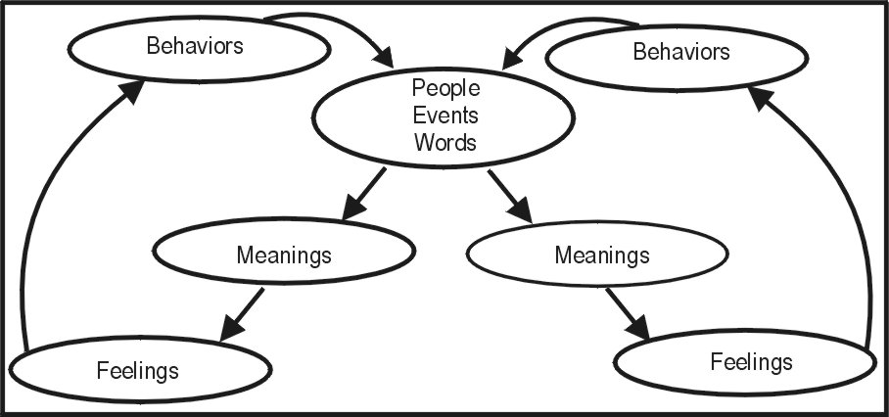
Since you choose to think, you can look at events, words, and what people do or say and decide for yourself what meaning you will choose to put to it.
With the advent of CABT EQ, now we can confront all issues from thoughts, feelings, and behavior. For example, a true story: The 13-year-old girl was supposed to be getting ready for her first formal dance. But, she did not want to go! Finally, the mother figured it out. She did not want to go because she was “flat as a board.” Her mother said, “Do not worry, I will fix it. We will buy you a brand-new formal dress, let you wear grandmother's genuine pearl necklace, and we will put cotton in all in the right places, and no one will be able to tell.”
When the time came, she walked over to the junior high school with the formal dress, genuine pearl necklace and all that cotton in just the right places. In less than a half-hour, she was back crying and all upset. “Honey, what happened?” Her response was, “he asked me, are the real?”
Her mother responded with, “Of course they are real. They are grandmother’s genuine, pearl necklace.” With that recognition, what she believed changed and what she was feeling changed. So, as Marcus Aurelius said, “And, it is in your power to wipe out that judgment now.” If a 13-year-old girl can change what she thinks, so can you!

When I draw out that interaction, this is what it looks like.
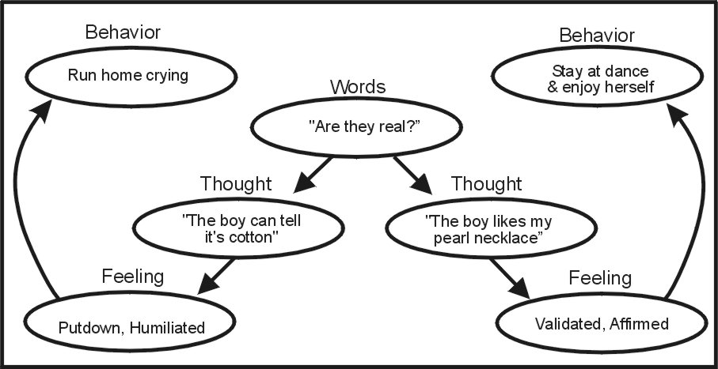

Apply: Remember an event from your past where your feelings were hurt and you felt angry and depressed. Draw out the model from above and insert an Event (people or words) that was painful and made you angry. Now, look at all the different Meanings that you could choose to think. As you change different Meanings, notice how your feelings change.
The more EQ that you learn and master, the more you will be in control of your life. No one will be able to “push your buttons” or make you feel bad again.
EQ is not hard to understand, but it is difficult to apply and will take years of practice. During this time, you will make many errors. “To err is human, to forgive is divine.” When you do not do what you know to do, will you allow yourself to see it as a stepping stone to your growth?
Apply: Never tell someone that you are sorry! To say that, is to say you did something wrong. You need not make yourself wrong. Just saying you are sorry gets old very fast. “Well, I said I am sorry!” Hearing that over and over with nothing changing gets old very soon. So, never say you are sorry UNLESS you tell the person how you will do it differently next time.

You can contact Dr. Downing at:
Email: docdowning103@gmail.com

