MAKING PEACE WITH ANGER
Your Own and Others, Too
Part 1 of 2

Why would I want to make peace with anger?”
Most people are afraid of anger and are not willing to make peace with anger. If someone starts raising their voice, notice how many people become very uncomfortable, and want to shut down any expression of anger. “Anger is bad. Anger is a sin. Anger is dangerous.”
What memories do you have as a child seeing or being involved in angry situations. Did you feel safe and supported? Or did you feel threatened and scared? Did you see violence connected with anger? Did someone leave because of the anger? Do you believe any of these childhood experiences could be affecting you today?
Even if you wanted to make peace for some reason, there are two problems with doing that. First, you cannot make peace with anger unless you recognize it in yourself and in others. For example, anger is often denied or rationalized away, such as, “I am not angry; I am just upset.”
Because many people see anger as bad, sinful, and out-of-control, they will cover up their anger by blaming others and using a euphemism like “upset.” “I’m not angry, I’m just pissed off.” “You made me upset.” You hurt me, (and now I hope you get what’s coming to you).”
Second, you cannot make peace with anger if you are afraid of it, both in yourself and in others. “When someone is angry, someone else always gets hurt.”
Let us start by recognizing anger in yourself. But you say, "I never get angry; I just get upset." All people feel angry, it is part of being human! Anger comes in degrees such as annoyance, irritation, frustration, and so on up to hate and rage. I had one of my clients tell me, “I got so upset that I cleaned the whole house!”
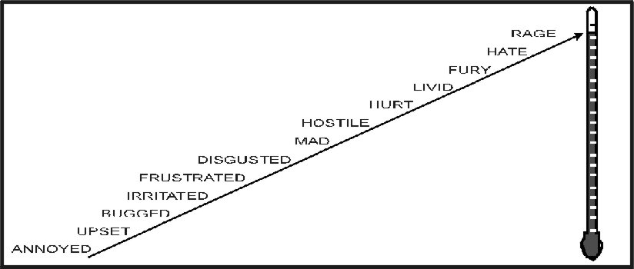
When it comes to anger, all people have a full range of feelings. Birds fly, fish swim, and people feel. However, it is possible to repress your feelings to the point that you are no longer aware of specific feelings.
When you do this, then that feeling will manifest in some other form, such as physical symptoms Conversion Disorder, also known as functional neurological disorder, is a condition where psychological stress manifests as physical symptoms. These symptoms can be quite dramatic, but no underlying physical cause exists. Here are some common conversion symptoms:
- Blindness or blurred vision
- Headaches or backaches
- Deafness or hearing loss
- Loss of touch sensation (numbness or tingling)
- Difficulty swallowing
- Loss of smell
- Weakness or paralysis
- Tremors or shaking
- Muscle spasms or tics
- Seizures (non-epileptic)
- Difficulty walking or coordinating movement
- False pregnancy
- Loss of memory or consciousness
Of course, all these symptoms can also be caused by physical problems. A medical diagnosis is important to determine whether the symptoms are organic or psychological (conversion symptoms).
Another way feelings come out when repressed or denied is through passive-aggressive behavior. The bumper sticker illustrates this: “I don’t get angry, I get even.

To reclaim feelings that have been repressed, such as anger, you will need to confront your false beliefs about anger. Here are some of the irrational and false beliefs that many people hold:
- Emotional Pain Is Terminal: When someone we love dies, we are often angry at that person for leaving us. Because this is an unacceptable feeling, it is denied.
"I can never stand to be hurt this way again." If you have ever been hurt so much emotionally that you hurt physically, then you know that this is a false statement because you experienced that pain and are still alive. Yes, I understand that you don’t want to go through that pain again and that you’re not going to volunteer to do it. However, that pain proved only one thing: What a gutsy, healthy person you are! If you went through it once, you could go through it again.
- Anger is both physically and emotionally hurtful to yourself and others. Not true! No one has ever gone to jail for being angry. It is how you express your anger that can put you in jail. It is not what you say, it is how you say it. In certain types of therapy, you can learn how to yell and scream in ways that strengthen your relationships with yourself and with others.
- "He who raises his voice first, loses." The concept of "losing face" is another misguided and false concept. Raising your voice does not mean you are out of control. Passionate people raise their voices all the time. A better idea would probably be, "He who loses control first, loses." You can be out of control without raising your voice. You can raise your voice and be in complete control.
Are you willing to recognize and accept your anger? Are you able to recognize and accept anger in other people? If you are, you are well on your way to peace with anger. The only people who never feel any degree of anger are dead! Or, they are lying to themselves.
There are no good feelings or bad feelings. What you do with your feelings can bring either peace or conflict to your life. Mahatma Gandhi was a truly angry man. He hated the British presence in India. Nelson Mandela used his anger to destroy apartheid in South Africa. Martin Luther King used his anger to lead the fight against segregation in America.
The goal is not to get rid of anger. It is to use anger and hate in nonviolent ways to change the world toward peace.
Feelings are not good or bad! They just are.
The martial art of Aikido has a variation in Verbal Aikido that uses words to accomplish the goal of disarming your "opponent." Both are performed by blending with the attacker's motion and redirecting the attack's force rather than opposing it head-on.
Verbal Aikido aims to strengthen relationships, help resolve conflicts, and bring others emotionally closer. To do this, you need to be clear about where you are coming from and where the other person is coming from. This requires you to be aware of what you feel when you feel it and to be willing to accept all your feelings and express them constructively.
To do this, it is helpful to understand the "To Me" rule clearly. This rule has two parts. The first part helps you not take anything that is said or done personally.
The To Me rule states that what someone says about me says NOTHING about me; it only tells me about you. Some examples: If someone says to you, "You have three heads and fifteen legs, " what did they say about you? NOTHING! What have they said about themselves? That they probably have a mental problem.
"You are so ugly that you would scare a mud fence." Now, what are they saying about you? NOTHING. Both are untrue, so how do you take the second one personally and write off the other untrue statement that is not about you? So, what did they say about themselves? Perhaps, for some reason, they are incredibly angry at you.
"You are the most beautiful person I have ever seen." Now, what are they saying about you? Still NOTHING! In communications therapy, we learn that two people sitting side-by-side can see things very differently. So, anything that they say is just their viewpoint.
Apply: Think of a specific time when someone has hurt your feelings, especially badly, by what they said or did. What did they say about you? If you cannot say NOTHING, you need to reread the To Me rule.
Here is the other side of the To Me rule. Whatever you say about someone else says NOTHING about that person, but it says everything about you. If you were to say, "The President is a sexist, racist, narcissistic, homophobe." What did you say about the President? NOTHING. However, I learned a lot about you as an angry person who wants their way at any price.
A word to the wise: whenever you are using putdowns, name-calling, or sarcasm, what you are telling those who are listening is that you are judgmental, angry, and perhaps a scary person to be around.

You can contact Myron Downing PhD:
Email: docdowning103@gmail.com
More articles: https://PositiveMentalHealth.Online/DocsDocx/ .

