HOW TO STOP THINKING NEGATIVE AND
DESTRUCTIVE THOUGHTS

The key to stopping unwanted or intrusive thoughts is Emotional Intelligence.
Emotional Intelligence—is 1st being aware of what you think when you are thinking, (you cannot change something you are not aware of). 2nd, being able to accept the feelings that you are feeling resulting from what you are thinking, and 3rd, choosing acceptable behaviors and reactions based on those feelings.
Once you know what you are thinking and understand that what you are thinking makes you feel the way you do, choosing to think something differently is critical to your work and life's success.
EI also increases your understanding of others: what motivates them, how they work, how to work cooperatively with them, and how to inspire them to reach their potential.
The University of Maryland's Robert H. Smith School of Business created a wonderful checklist that points out where you are not using your emotional intelligence. A deficiency in your emotional intelligence will result in some of the following behaviors. Check yourself on this list to see if you are lacking or are not accessing your emotional intelligence.
__ You quickly blame other people for your problems or errors.
__ You don’t take feedback well, getting defensive or shutting down when the comments are offered.
__ You get impatient and frustrated when you think others misunderstand or do not appreciate what you are saying.
__ You don’t forgive people easily.
__ You are quick to judge people on how they look, what they wear, how they talk, or what they do based on what you think is right and best.
__ You are very selective with whom you will spend time and share your thoughts. You look for people who are in your same “class.”
__ You give your opinions early in a conversation and hold on to them no matter what anyone says. “I may not be right, but I am never wrong.”
__ You constantly declare that you don’t care if people like you.
__ You think emotions are overrated. and it doesn’t matter what others feel.
__ You have a short fuse.
__ You have a problem sleeping because you ruminate.
__ You struggle with depression and anxiety.

With emotional intelligence, you will discover:
- I can accept others and do problem-solving.
- I forgive by taking the judgments off those I have judged.
- I can take full personal responsibility. If it's my fault, I can change it.
- I seek other points of view.
- I can accept the gray areas of life.
- I can understand, accept, and explain my emotional reactions.
- I use emotions appropriately to inspire and make others feel comfortable.
- I admit and learn from my mistakes. The more mistakes I make, the more opportunities I have to learn how to do it differently next time.
- I do not take things personally. I do not get my feelings hurt.
- It is the way I think that causes the problem.
- I have learned that if what I say and what I do don’t match, then I am lying to myself.
Short of attending a training session, here are some things you can do now to increase your emotional intelligence:
Track your emotional states for three weeks. Set an alarm to go off on your phone or computer twice or thrice daily. Write down what emotions you are feeling.
Look deep into your body for anger, fear, betrayal, embarrassment, or disappointment. Break down your happiness into more specific feelings such as pride, appreciation, or hope. Look for more than one emotion. For example, you could feel happiness and jealousy simultaneously. You can find a list of emotions below.
Feeling Words
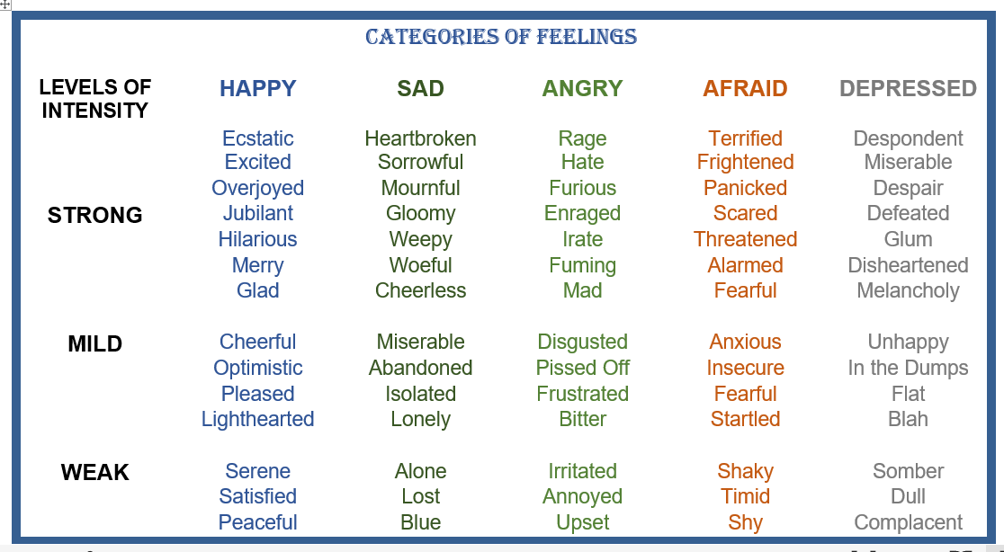
Next, check your beliefs:
- What are you thinking or believing that is creating your feelings? (Such as anger, anxiety, worry, depression, and guilt.)
- What emotional events in your life, traumatic or happy, have created your feelings?
- What other meanings or beliefs have you put on the events that happened to you? (“I was overprotected therefore, I am afraid to do anything.”)

Now it is time to Take Control of Your Life.
Below is a worksheet created by Matt Pearlstein on how to identify what you think, feel and then the behaviors that resulted. Study carefully and then make your own chart.

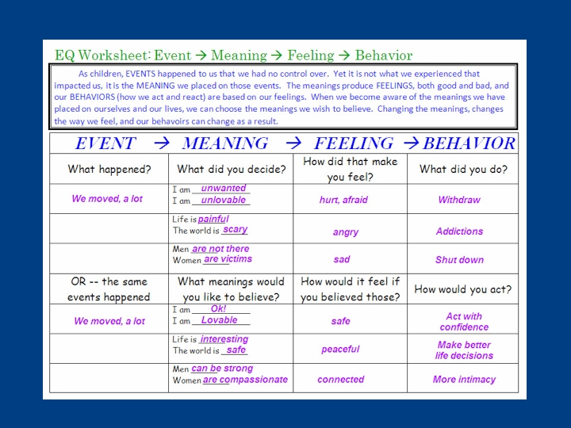

Myron Doc Downing PhD
Website: DocDPhD.com
Email: docdowning103@gmail.com

