Myron Doc Downing PhD
Author | Therapist | Coach | Seminar Leader | BA, MSW, PhD



How to Fall in Love and Stay in Love

“Love is a complex set of emotions, behaviors, and beliefs associated with strong feelings of affection, protectiveness, warmth, and respect for another person.”

Most people have no idea how they created their feelings of love… they believe “it just happened.”

Falling in love is not an event . . . Falling in love is a process!

But before we discuss the love process, it is important to understand what love is not!

False Beliefs About Love
- “Love just happens,” is the most common fallacy about love. This is because most people have no idea how they create the feelings of love.

- “It was love at first sight…” that is not love, it is infatuation. Can you really be in love with someone you do not know?

- “The intensity of our love feelings will guarantee that our love will last.” Truth: almost 50% of all marriages end in divorce!

- “We are having sex, so it must be love…” no, that is lust!

- “Love is about not fighting…” The truth is that fighting is a part of every love relationship. You get angry most at the people you love the most. The opposite of love is not hate or even anger, it is indifference, not caring. Most fighting is about some person not living up to your expectations. You get angry at things/people over which you have no power. How the fight turns out is not about what you say, it is how you say it!

- “We’ll marry and live happily ever after…” Marriages end for a variety of reasons such as, death or “growing apart.” The truth is that most people fall out of love because one or both forgets about how they created their love feelings in the first place. If you created your feelings of love the first time, then by doing the same thing again, you can create your feelings of love again!

How to Fall in Love and Stay in Love… The process…

How do you create the feelings of love? How do you create the feelings of euphoria, elation, joyfulness, excitement, etc., and how do you maintain them?

This is what you will need to know to create a great and permanent love relationship.

Five Important Steps:
- Deciding to be open to starting a new relationship.
The first step is to risk being rejected! Fearful people who are afraid of being hurt will not get close enough to anyone to get rejected.

Once you have risked being vulnerable and choose to approach the other person, then it is up to that other person to make the decision to accept or reject you.

If the person accepts you, then the two of you can take the next step in the Love Process.



- Time together…

It is not just being in the same room. It is a special type of time together. There is an old joke that you can walk into any restaurant and tell who is married and who is not. Look around the room at couples staring out the window or just blankly staring at nothing. They are the ones who are married. Now, see the two people whose eyes never seem to leave each other, who are totally absorbed in each other – they are not married. This is the kind of “time together” that I am talking about.

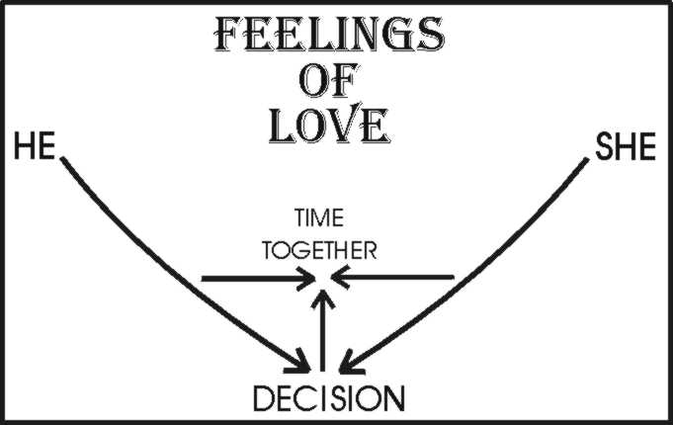

- Honesty…

Honesty starts with being honest with yourself, then sharing that honesty with another. For a couple to be in love, they must know each other, NOT in just the superficial areas that are shared with everyone.

Being honest is like going to the center of an onion; there are layers or degrees of honesty. “It’s a beautiful day” is honest, but it is superficial. That level of honesty you would share with just about anyone.

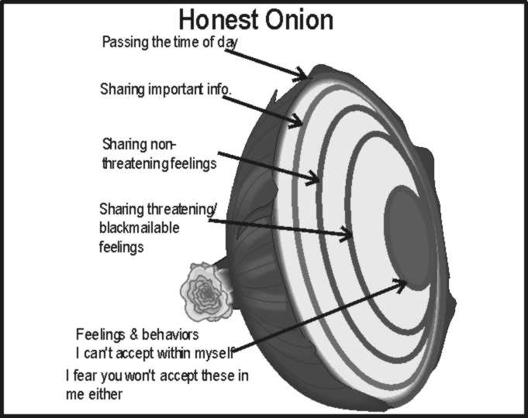

The next level of honesty would be the historical report: “and he said. . . then she said. . . then the cops came.” Going deeper still is where I tell you personal but non-threatening information about myself. “When I was going to Portland State, I used to buy and eat horsemeat.” “I had my tonsils removed when I was 16 years old.” “I really love Limburger cheese.” “I am told that I sometimes snore.”

The next level is your deepest level. It is the level where you become afraid to share your own feelings because “they may use it against me at some time in the future.”

It is at this level that most people stop the Love Process and their walls go up. Sex researchers, Masters and Johnson, found that this is the level where most couples started substituting sexual intimacy for real emotional intimacy.

- Acceptance….

Once you have been open and vulnerable to your center, it is out of your hands. Now, it is up to the other person to accept or reject your feelings. Once your feelings have been accepted and you have let acceptance in, then you will feel the feelings of love; you will have “fallen in love.”

Acceptance needs to go both ways. Both parties need to be accepting of the other’s beliefs, feelings and behaviors.

A word of caution, acceptance does not mean approval. If you choose to live with an alcoholic or a person with other addictions, are you willing to accept that behavior? Or, do you keep nagging the person (nonacceptance)? Yes, you can love somebody without accepting them. However, love without acceptance feels hollow.

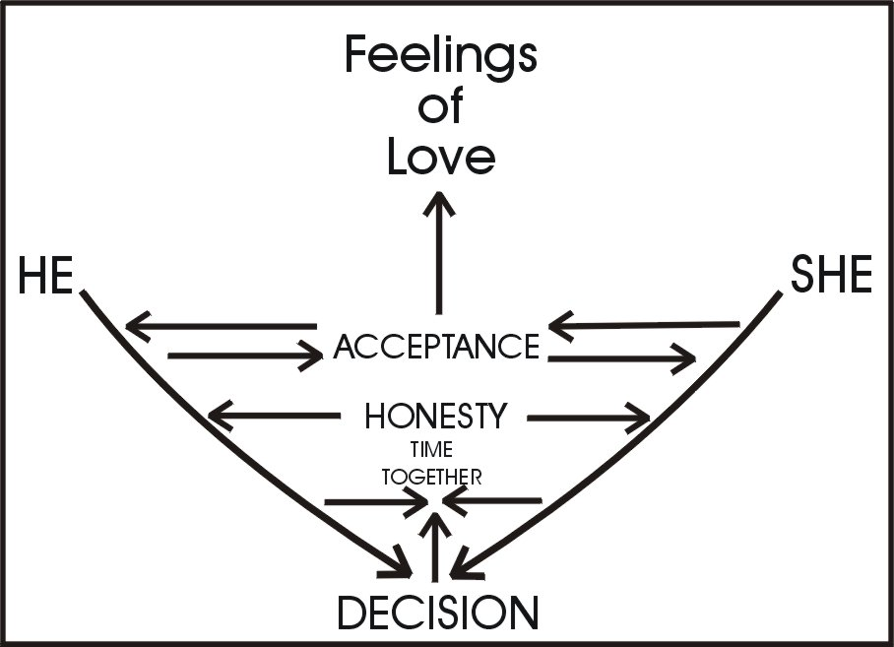

- Making your love feelings last…

The feelings of love need to be continually generated or they will fade away. The Love Process is a continuous ongoing process of both sharing time together, and both being honest and vulnerable to their very core. Both accept their own feelings and the feelings of the other person and then both do it all over again, and again, and again.

The test of truth: Take this template and compare it to your own love relationships. Can you see any of your relationship in the Love Process?
Did you spend time together? Were you willing to be honest to your core?
Were you willing to give and receive acceptance?

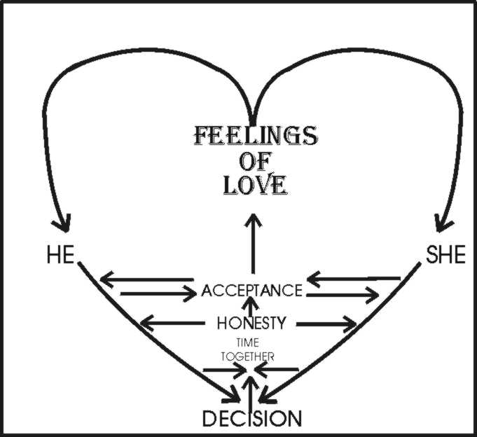

The Key Takeaways…

To create the feelings of love and to make them last, requires five important steps:

  - Decide to push through your fear and anxiety and be open to a new relationship.
  - Weekly spend time together without distractions.
  - Use that time to be open and honest with yourself and your mate. Share both negative and positive feelings, thoughts and desires.
  - Accept the other person’s beliefs, feelings, behaviors and you will be on the road to a loving and lasting relationship
  - To ensure that love will last requires a joint commitment and continued application.
If the two of you practice the love process, you will develop “loving feelings” which will get you over the rough times in your relationship. To ensure that love will last requires a lifelong commitment by both parties in the relationship.

You can contact Dr. Downing at his
email: docdowning103@gmail.com
website: DocDPhD.com

