Is What You Think
More Important Than What You Feel

Orr
is what you feel more important than what you think? In EQ, we learn that before you say or do something (behavior) you feel something first. Or, to say it another way, behind every behavior is a feeling.
However, what you think determines what you feel. If what you think is faulty, then what you feel will be irrational, illogical, unreasonable, ridiculous, unsound, unscientific or outright foolish.
Basing your behavior on feelings that are illogical, unreasonable, ridiculous, and unscientific can lead to unsatisfactory outcomes. You will soon discover that what you say and what you do, do not match up, and will cause confusion in you and in those around you.
The client was angry at her husband. “He knows what’s important to me and he deliberately will not do it. He says he loves me, but I feel that he doesn’t even want me around, because he knows what makes me feel loved and will not do it.” I thought that sounded like a reasonable request. But, it seemed like there was more to it.
She went on to explain that there were dust bunnies under the bed and and if they were not removed on a regular basis, they would grow and attack her. [Not very logical.] “If he really loved me, he would vacuum under the bed every night.” When something is illogical or does not make sense, it is hard to convince someone else to go along with what you want.
What you feel has nothing to do with what people say, what they do, or who they are. Your feelings have only to do with what you think, believe, expect, and conclude. It is what you decide about what they say, do, or who they are, that creates your feelings.
See the diagram below. There is an external stimulus (words, people, events) you will then place a meaning or interpretation on what was said or done based on where you are emotionally, and on your past experiences. Depending on the meaning that you put on that stimulus (“It was good, “It was bad”) the decision that you make about what it means will determines how you feel. Whatever feelings you have will then determine the behavior that you choose. You will then start looking for more words, events, or people that will reinforce the meanings that you have chosen.
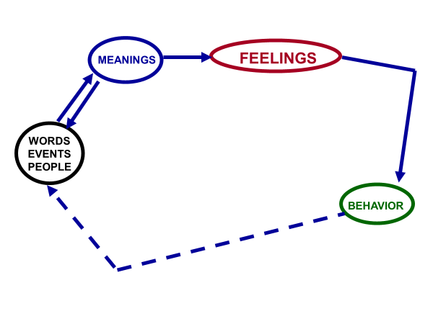
If this concept were not true, then it would be true that people can make us upset, hurt our feelings and make us angry. If people can make us upset, hurt our feelings or make us angry, then who is controlling our feelings? They would be!
If they are in control of our feelings, then what control do we have? None! The moment we believe that they are in control of the very core of our being (our feelings) what do we feel? (We feel powerless from the belief that we are not in control). It is our thinking that creates our feelings of powerlessness.
Where did you get this idea or belief?
Did you ever have your mother or dad say something like this to you when you were a kid? “You make me so angry!” Or, “You’ve done it again, you got me mad.” Or, “You have to be quiet or you will upset your father.”
These kinds of messages are very common – – and, they are ALL lies! The truth is, you have never upset your folks. Well, you might say something like this in retort, “I did something wrong and if I hadn’t done it, then they would not have been upset.” And, I would agree with you. But the question is not “Do parents get mad at their kids when they do something wrong?”
The question is: What is the importance of understanding this concept of who is creating the anger, you or your parents? Knowing the answer to this question will keep you from becoming a reactor. And, knowing to whom the anger belongs can prevent you from creating a dysfunctional relationship and help you to create a functional one.
It will allow you to increase your willingness to be open and honest about what you are thinking and feeling. It will also allow you to listen to what others are saying without taking it personally – – it will help you to not be afraid of hurting someone else’s feelings, because they are responsible for putting their meaning on what they are hearing you say.
In close relationships, we often hesitate (or refuse) to share our thoughts and feelings with our counterparts, because we don’t want to hurt their feelings, or we don’t want them to hurt us when we share our feelings with them. So, we settle for dishonest relationships in the name of preserving the relationship. The problem is that the purpose of a relationship is to provide the means by which we can increase our sense of boldness, intimacy, safety and security, worth, satisfaction, empowerment and goodness.
Without a open and honest relationship, all we have is a practical arrangement, not a covenant and not a two becoming one. Or worse, what we have is the manufacturing of feelings of fear, disappointment, guilt, shame, powerlessness, and isolation. Then, we point our fingers at the other person to hold them accountable for how they made us so upset.
It is a vicious cycle that can only change when you change your thinking. You are the one who is putting your meanings on other people’s words and actions.
My experience tells me that most people do not understand this concept. And worse, that we have been taught lies about what a good relationship is. We have been taught how to manipulate, lie, deceive, evade compensate and blame. Most of us are experts at this, having learned well from our parent’s dysfunction.
If you had kind, loving, caring and assertive parents, you have been blessed. They may be, unfortunately, the exception to the rule. They refrain from hitting you when they were angry. They did not threaten or condemn you, nor did they molest you. They encouraged you, included you, picked you up when you fell down and they would listen to you when you had something to say.
They got mad, but they would try to explain to you what they were upset about. You probably realized, at some point, that they cared. And, that they were angry because they cared. They were angry because they loved you!
This article is simply to get you thinking about yourself and others, to consider that “all behavior, no matter how destructive it may appear, has positive intent.” All of us want to feel safe, secure, satisfied, courageous, connected, worthy, and hopeful. How we accomplish this is the difference between war and peace.
So, which is more important, the way you think or your feelings? Your behavior is just a symptom of your thinking! This is not a new concept. The Stoic philosopher, Epictetus (55 AD) said,
“Men are disturbed not by things,
but by the view they take of them.”

And, Shakespeare said in Hamlet,

“There is nothing that is good or bad but thinking makes it so.”

Myron Doc Downing PhD
Specializing in Relationships, Depression,
Anger Management & Anxiety Disorders.
Email: DocDowning103@gmail.com
Website: DocDPhD.com

