WHO MAKEs YOU ANGRY
AND HOW TO STOP IT

Most people believe that others are responsible. “I hit my wife because she made me so angry.” “I killed my husband because he abused me for years.” “I shot him because he disrespected me.” “I drink because my wife nags me all the time.” “I don’t want to fight but my wife knows how to push my buttons.”
If someone can make you angry, then who has the power? They do!
And, you get to be the victim!

The parents of a 16-year-old girl brought her to me. She had been thrown out of Clovis High School. I asked the girl how she got the high school to choose her out of over a thousand girls to be the one who got thrown out? “The principal doesn’t like me.” Out of all those girls at your high school, how did you get the principal to choose you as the one that he doesn’t like? She struggled with that question for awhile and finally said, “I guess he noticed me because I punched this other girl’s lights out.” Wow, how did she get you to punch her lights out and then be thrown out of school? “She made a face at me.” So, anytime that this girl wants you thrown out of school, all she has to do is make a face at you? She must be a very powerful person to have that much control over your life! Then, we talked about the difference between being an actor and a reactor.
After several weeks of meeting with me, she decided that she would not give that much power to anyone ever again.
To have personal power in your life requires
that you change the meanings
that you put on events
that happen in your life.

Here is another example: For there to be a fight, two people must want to fight! If one person chooses not to fight, there can be no fight. If somebody is hitting you and you do not hit back, that is not a fight. You may be getting pummeled, but that is not a fight.
Sometimes this gets very confusing, especially if someone such as a parent or policeman believes that it is their duty/responsibility to control someone else. Parents may use physical force with a child because they feel that child disrespected them and did not obey. The police are often caught in the same dilemma. “He wouldn’t follow a simple order to show me his hands, then he spit on me, called me a pig and started to run away. What was I supposed to do?”
Back in the 1960’s, there was a lot of that going on. One of the ways that the police handled their emotions was to change their beliefs. PIG now stood for Pride, Integrity, and Guts. When someone called them a pig, their response would often be, “Thank you.” They were choosing to be actors rather than reactors.
Today, there are groups that are looking for confrontations. If one group shows up for a rally, then a counter group is sure to be there to confront them. From observation, it appears that both groups want confrontation which can lead to violence, and then they can blame each other.
There are some advantages to not being responsible for your own behavior. One of the biggest advantages is that you do not have to change. If it’s not your fault, then you can keep doing what you’ve always done. You can feel sorry for yourself and even, maybe, get others to feel sorry for you.
When my children were small, I noticed a pattern developing. Tracey and David seemed to always be getting into it with each other. Tracey was the oldest, about six years old, and David was not quite two years younger than her. Every few days, David would come running to me with tears in his eyes, crying and say, “Tracey hit me.” Sometimes, there was some bruising that proved that Tracey had hit him. Tracey was usually sent to timeout as her punishment. No matter what I did, it seemed that nothing could get Tracey to stop hitting David. If anything, the whole cycle just seemed to escalate and get worse as the weeks went by.
Then, I remembered what my grandfather told me, “If what you’re doing does not work, you have two options. 1. You can do it harder (yell louder and/or assign longer timeouts). 2. You can do it different.” Since the first was definitely not working, I started looking at the second option.
The next time David came crying to me that Tracey had hit him, I dropped what I was doing and sat down on the floor and asked David, “How did you get Tracey to hit you?” At first, he vehemently denied that he had done anything. Finally, after I wouldn’t back down, he admitted that he had been in her bedroom and “messing” with her stuff.
I responded with, “David, that is great insight! Now that you know how you got Tracey to hit you, anytime you want Tracey to hit you, you know what to do. David, you are brilliant.” This was said with all sincerity and without any sarcasm. Variations of this statement to David were repeated each time he got hit.
Of course, the physical violence did not stop at once. But, within about six weeks, there was no more hitting and no more “messing in her stuff.” What I did not realize when the cycle was in full bloom, was that I was rewarding David’s behavior by punishing Tracey. He was getting exactly what he wanted, my attention and he had power over Tracey.
As I watch the news, it feels to me like I am back in the cycle with Tracey and David. Often, I wish I could be there to ask the question: “How did you get the police to choose you, out of all those people, to arrest?” I wonder if beating up an old homeless man, robbing a store, and then hitting a policeman and walking away might have made you stand out?
The police have a huge handicap. The only time they can legally shoot someone is when their own life is being threatened. So, it is perfectly okay to punch a cop in the face and then turn and run like hell. Or, you can walk around the street shooting your gun, and when the police come, run away, because you are not a threat to the policeman. Nowadays, there does not seem to be a level playing field between the cops and the bad guys. Now, all bad guys are good guys, once they been shot.
The truth is that Tracey could have, on her own, stopped hitting David. David could then escalate the conflict “messing” with more of Tracey’s things. The problem was that the behavior, “messing with Tracey’s things,” was not the real problem, it was the symptom. What David really wanted from his big sister was her attention. One of the things that I learned was that negative attention is better than no attention at all.
When you watch these horrendous events played and replayed on TV, maybe, it is time for us to start asking what do these people really want? Often, solutions are given such as: pull the police out of the violent areas and let them kill each other until the community is willing to accept that “ratting out” the gang members is a solution. The alternative is what the mayor said, “We need to do the moral thing. We need to invest more money in the community. We need more and better schools.” The problem here is that these kinds of solutions address only the symptoms, not the cause.
Negative attention is better
than no attention at all.

All violence comes from feelings of powerlessness.
It doesn’t matter whether it is child abuse, domestic violence, school shootings, or gang shootings, the common thread is feelings of powerlessness. Solutions that only address the symptoms do not work. Is it possible to change what a person feels about themselves and their world?
How do you address the problem of powerlessness in individuals? For therapists like Freud, Skinner, Jung, and Ellis, feelings were a “black box” that therapy could not deal with directly.
Over the last 40 years, this concept has been changing. Now we know that feelings can be changed by changing what we think and/or believe. We are now looking at therapeutic approaches that encompass the meanings that we, as humans, place on the events and words. These meanings then determine what our feelings are.
Using himself as an example, Matt filled out his own worksheet, see below. Matt Perelstein took this concept of EMFB and made it into a worksheet with more specific questions/prompts. Matt now uses it in his New Directions workshop. The idea is to make changing your meanings and feelings as simple as possible.

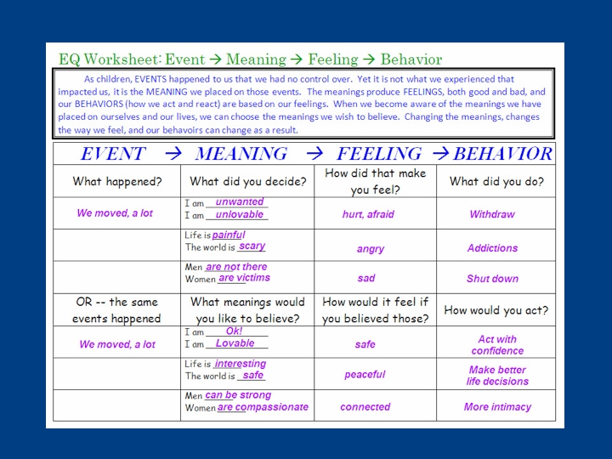
Now, on the blank form below, answer the worksheet questions for yourself. Start with some emotional event or repetitive events that happened to you before the age of 16. Working from left to right, fill out your own sheet until you reach the bottom of the page. Consciously or unconsciously, you are always choosing what things mean to you. As a child, it is almost impossible to change the meanings of what happened to you. But, while it still may be difficult, as an adult, you can change what things mean to you.
Next, make a list of as many traumatic, life-changing events as you can remember. Take each one of the events on your list and systematically fill out a new sheet for each one.
Watch how your life starts to make more sense, based on stuff that happened to you in your past.
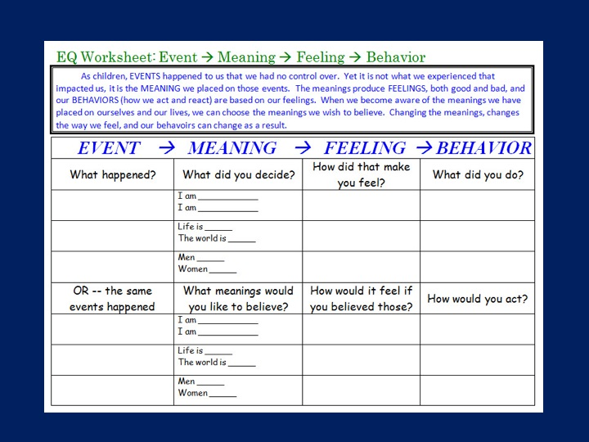

If you are pained by external things,
it is not they that disturb you, but your own judgment of them.
And it is your power to wipe out that judgment now.
Marcus Aurelius, 121 AD Roman Emperor

NOW is the time to take back your power.

Myron Doc Downing PhD
Specializing in Building Relationships,
Alleviating Depression, & Anger Management.
Email: DocD@DocDPhD.com
Website: DocDPhD.com

