FEAR is in control of part of your life.
FEAR Be Gone
Part 4, Techniques to Unlearn Fear

Right Brain Therapy. Look around the room and select an object that is about 5 feet from you. Look at that object. Now, close your eyes and tell yourself that it is not there, that it does not exist! Did it disappear? Of course not. You can never talk yourself out of right brain pictures (flashbacks). You cannot use logic or rational thinking to erase that image/picture. Flashbacks are “pictures” that are seared into your memory.
The pictures that you see in the right side of your brain are seen and experienced as real and as happening right now. Your body will react to whatever picture it sees. If it is a pleasant picture of gentle waves breaking on a sandy beach, with white fluffy clouds on the horizon, you may find your body relaxing. If the picture that you see is of the last big fight that you had with your mate, you may find your body tensing and your neck becoming tight. You cannot wish the pictures/flashbacks away. However, there is a way to remove the emotional charge off of these pictures. I had a client who had been a gunner on a Huey Helicopter during the Vietnam War. After returning to the States, he would have terrible flashbacks, and some nights he would sleep in his closet, curled up with his rifle. The nightmares were that bad. For him, they were real and happening right now. The problem is how do you make something that is “real” disappear?
Let me illustrate it this way: In arithmetic, if you have a negative one (-1) and you add to that a positive one (+1) what is the total? (Ans: -1+1=0). There is a therapeutic technique that work on this principle. This technique can zero out the negative emotional charge that you find so distressing. This technique can be done in private practice but is more often done in workshops lasting from a weekend to a full week.
What happens in the workshop is that members are encouraged to “bring up” the trauma “picture” that is causing the fear and panic and to relive it. Then, with the group’s encouragement, the participant physically and mentally creates a new picture of strength and power.
To get the most out of one of these workshops, it is important to understand how your left and your right brain work. You want to be able to allow your left brain to be able to give permission to work on the scary pictures in your right brain. Because, your left brain tells you that you have already gone through and experienced that trauma once, so why in the hell would you want to do it again?
For 25 years, every Saturday morning at 9:30, I ran Huge Group Therapy. Huge group therapy was just that. Over the years, the group averaged 15 to 25 people. The group was set in a circle with 24 chairs backed up against the walls. If you got to the group late and all the chairs were filled, you got the privilege of sitting on the floor.
Huge Group was open ended. Participants were referred to the Group from my private practice, local judges and attorneys, word-of-mouth and New Directions (an affective, weekend workshop). Since the right brain cannot tell the difference between what is real and what is imagined, the goal was to create a powerful new experience using your physical and verbal power. Now, when you have a flashback your right brain sees two realities. One is powerful and in control, the other is traumatic, scary and overwhelming.
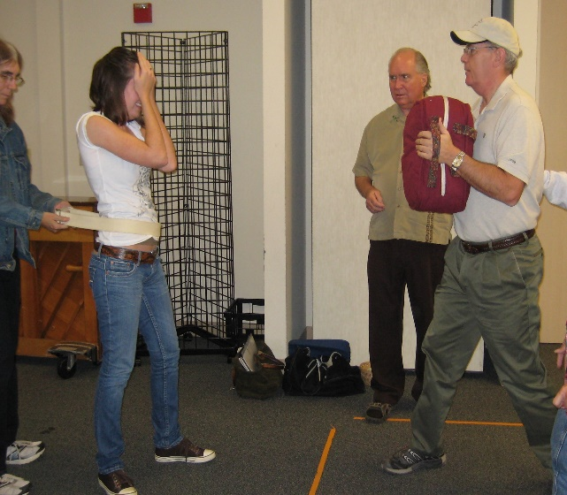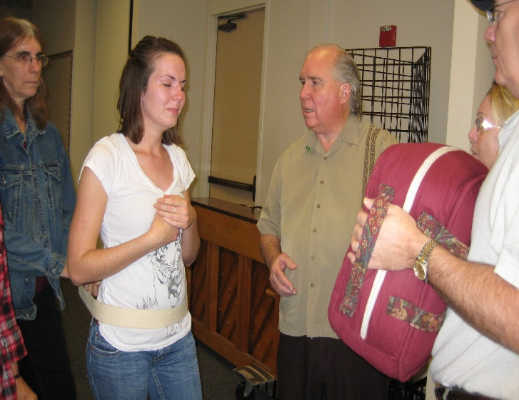
The first picture is facing your traumatic experience, – 1. Here is where you allow yourself to emotionally re-experience that trauma. In the second picture, preparing yourself to create a powerful, positive picture, + 1, in order zero out the picture of the traumatic event. Now, when experiencing a traumatic flashback, there is a positive “picture” of strength and power, side-by-side with the negative picture. Then, there is a sense of control and of being able to handle any similar traumatic events that might occur.
In right brain therapy, the emotional intensity of the initial trauma needs to be matched with the emotional intensity of the new picture. See the pictures below. (This started out to be just a demonstration of this kind of therapy, but it very quickly turned into an actual real-life changing experience. It is the young lady’s mother who is supporting her with the Posey belt.)
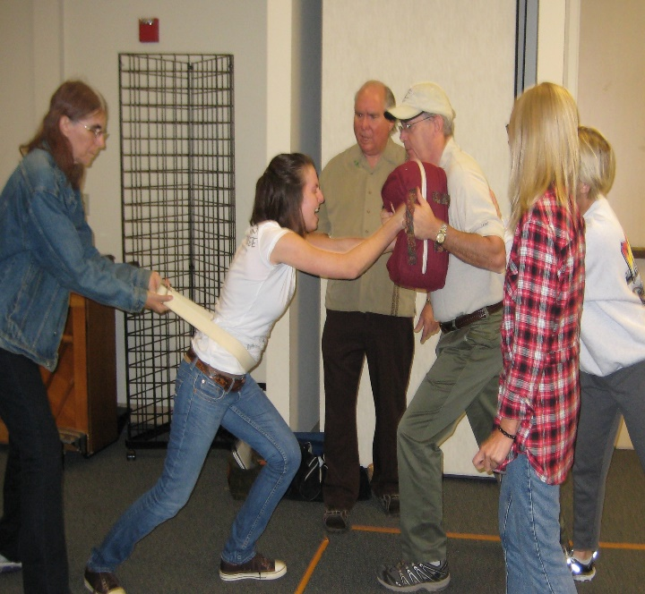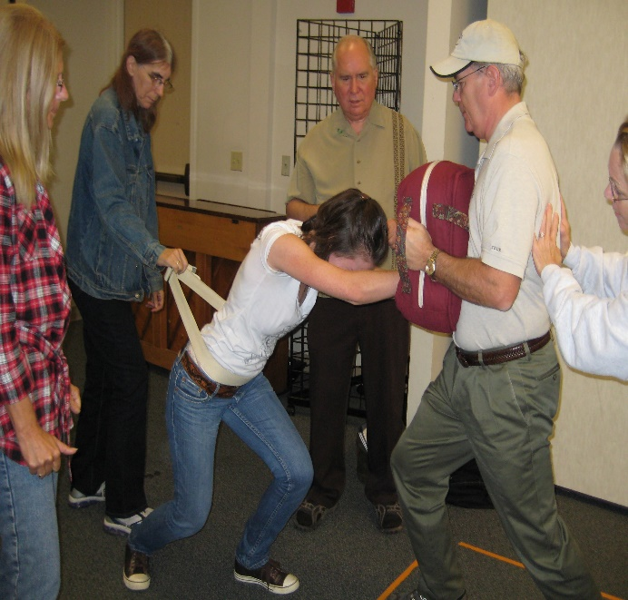
The use of the pillow to push against and the Posey belt to give support allows the participant to feel safe and supported and at the same time to be “totally out of control.”
The Verbal Rule says that feelings expressed verbally will take place and reduce in intensity and then are free to change. This rule is also called the 15-minute rule: You cannot be yelling, screaming, cussing mad for more than 15 minutes. There are a couple of exceptions: 1) If you are using your anger to manipulate someone. Then you can stay angry for days or weeks or until they change in the ways you want them to change. 2) If you are using your anger to keep from feeling your love feelings. This method is often used during break ups in relationships as a way of not being sucked back into a destructive relationship. 3) There are certain types of brain damage that will circumvent the verbal rule.
I have been doing this type of right brain therapy for over 30 years and I have never had any participants that could keep their anger going for more than 15 minutes.
In Huge Group, I would have the participant choose someone who reminded them of their perpetrator. That is the person who would hold the pillow. Different members of the Group, often, will get out of their chairs, circle the two people, and offer encouragement and/or use trigger words or phrases to help the participant to re–experience that trauma. During this time, other members of the Group may get triggered with flashbacks of their own. And, they may ask for time to work on their own traumatic issues.
After the creation of a new picture, you often can see the changes in the person’s face and body.
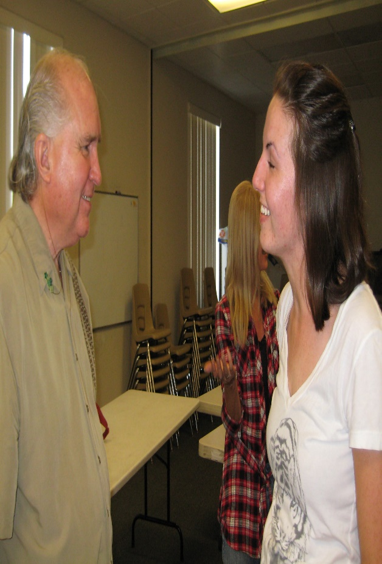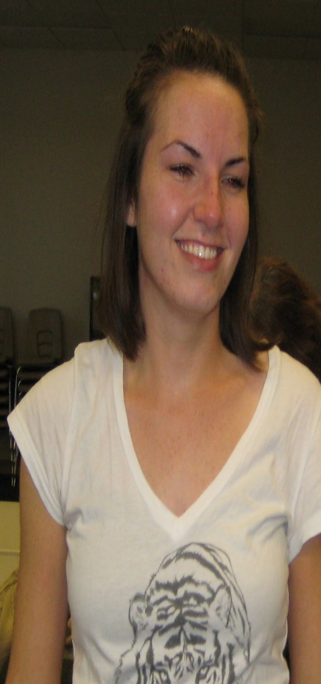
Either consciously or unconsciously, fear plays a big part in our lives. Most of us are aware of the first three: Fight, Flight, and Freeze. Would you like to have some alternatives to these three options? In part five of FEAR Be Gone, I will be exploring how you are being manipulated by fear.

Myron Doc Downing PhD
Specializing in Building Relationships,
Alleviating Depression, Anger management &
Dealing with Anxiety Disorders
Email: DocD@DocDPhD.com
Website: DocDPhD.com

